Project Specification Document

--------------------------------------------------------------------------------------------------- **Document Version 1.0** **Latest updated: 31-07–2022**

**Author: Suraj Singh**

**FlyAway- Become a Back-End Expert**

**Content**

**1. About this Document**

**2. Introduction and Objectives**

**3. Flow chart**

**4. Solution Overview**

**5. GitHub link**

1. **About this Document**

This functional and integration (FIS) document will enable you to understand the proposed solution of FlyAway.com

The content of the document will have a solution and its configuration details as it will be available for our client.

**How this Document is organized**

This document is organized into following chapters:

**Chapter 1 -** "Introduction" provides solution scope to be delivered to our client.

**Chapter 2 -** "Flow chart" provides how the user is interacting with the application.

**Chapter 3 -** "Solution Overview" provides information on Company Foodbox Pvt. Ltd., Components and Interfaces in system.

**Chapter 4- “GitHub link”** provides the information where the project is located.

**Contact Information**

FlyWay (An Airline Booking Portal) welcomes your comments and suggestions on the quality and usefulness of this document. For any questions, comments, or suggestions on the documentation, you can contact us at the following address:

|  |
| --- |
|  |

**2. Introduction**

This document describes the implementation of **FlyAway Application**(An Airline Booking Portal) and how its users can interact with the application.

**Objectives**

FlyAway is a ticket-booking portal that lets people book flights on their website.

**3. Flow chart**

The objective of this session to show how the user interacts with the flow of the **Foodbox Online Portal for ordering food online from Foodbox portal.**

Admin Login

Guest Page

Add Flight, Admin Password Change, Flight Reports, Booked history

Book Flight, About Us, Contact Us

Footer Page

**4 Solution Overview**

**Platform requirement**

The platform used for this project is the STS3 (Spring Tool Suit 3), Tomcat, MySQL Workbench and technologies I have used in this project are JAVA, Servlet, JSP, HTML, CSS, Maven and Java Script.

**UI and Functionalities for Users of Foodbox.com:**

**Welcome Page:**

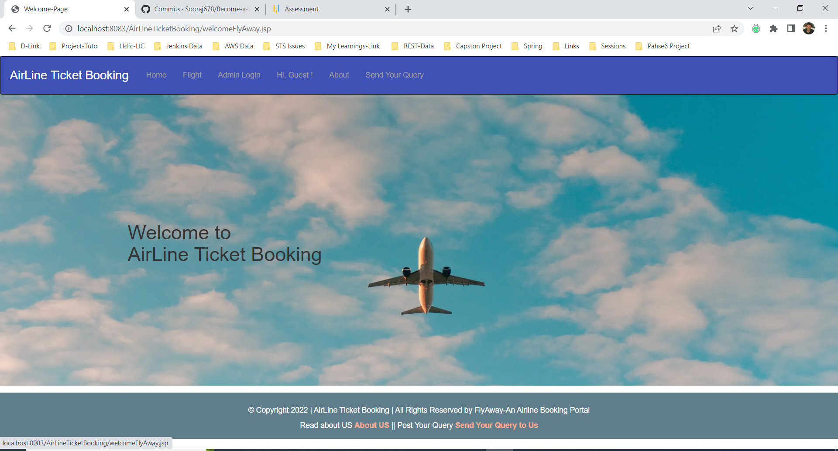

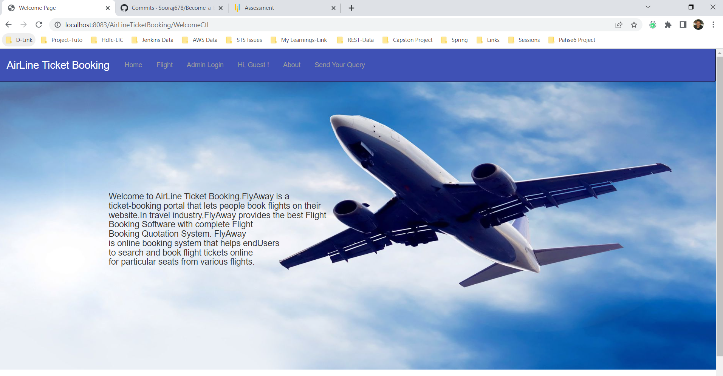

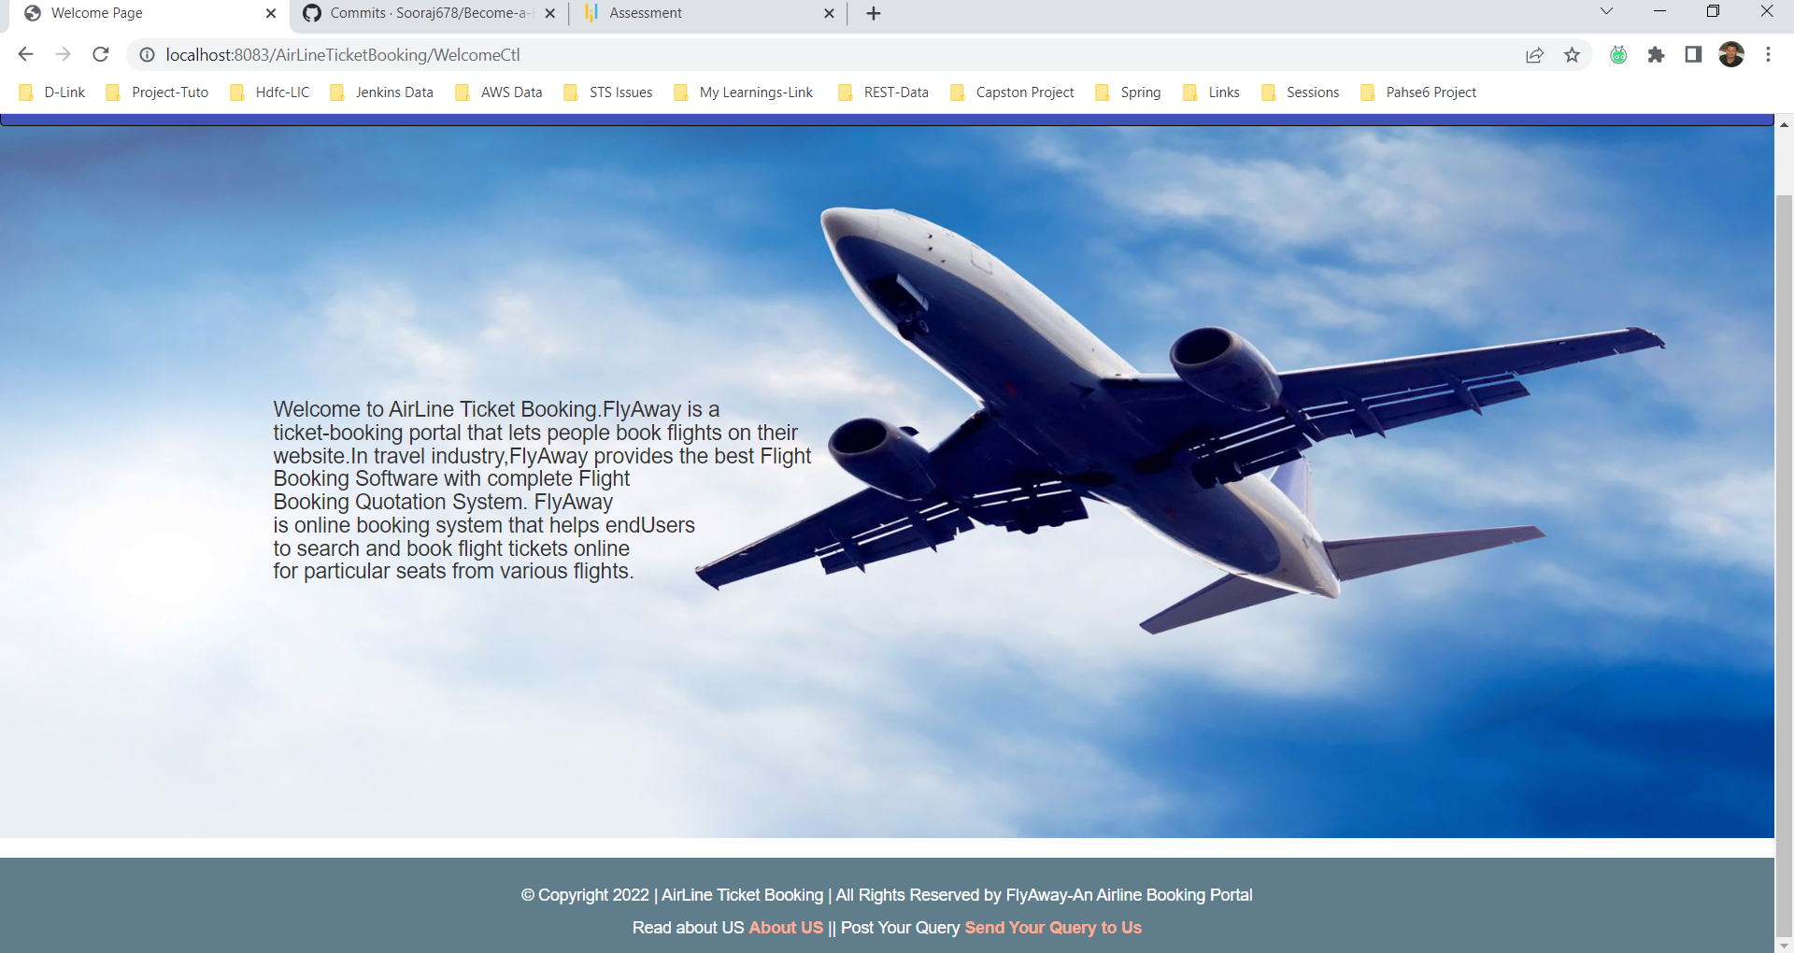

***User-View or Guest View***

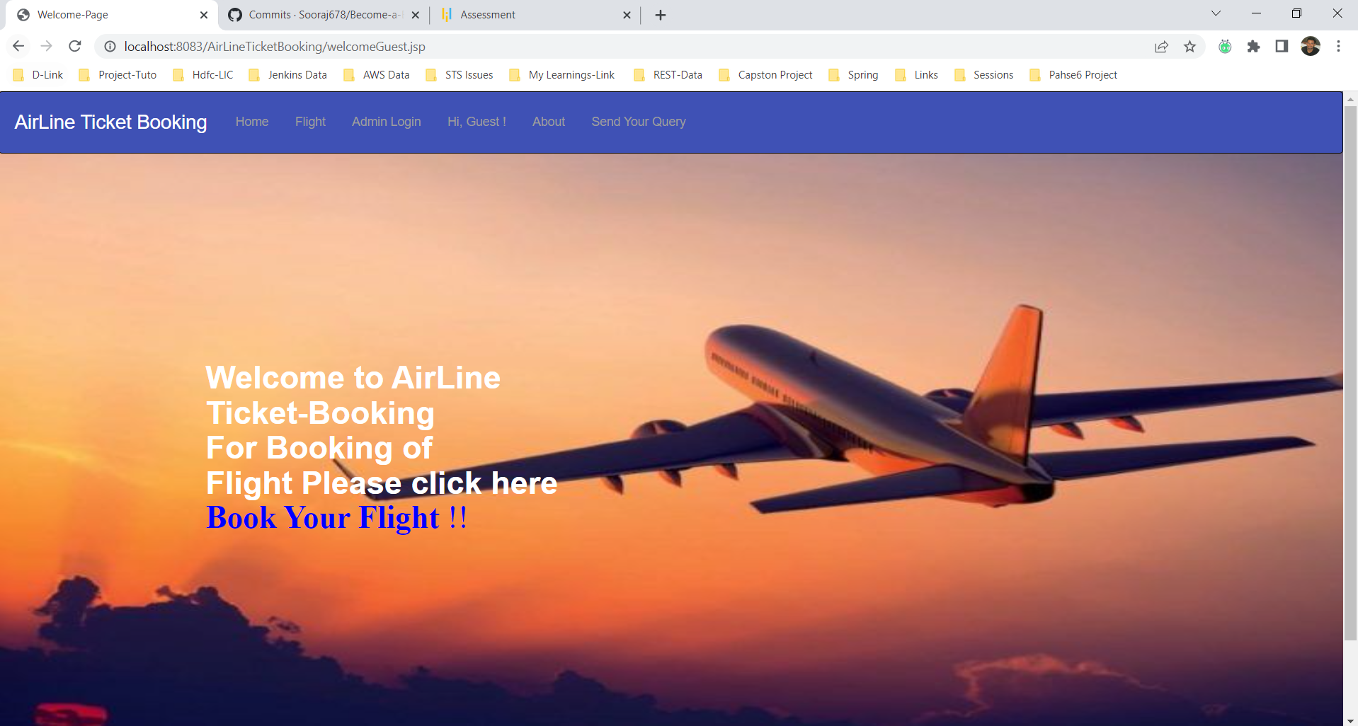

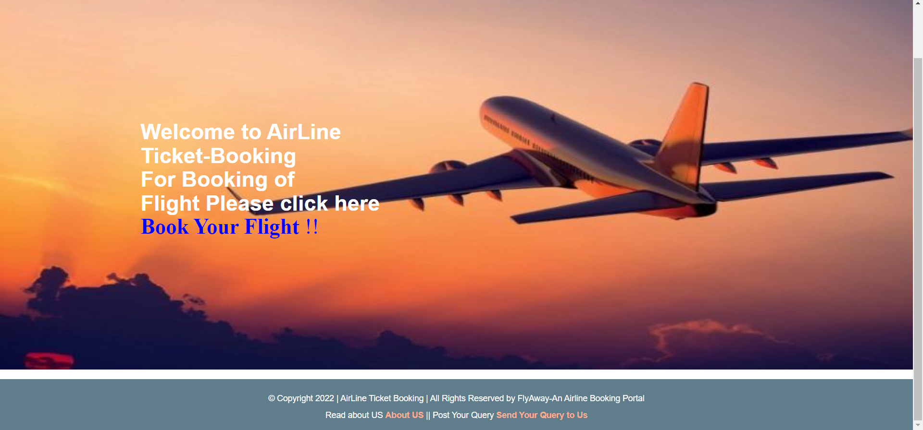

***About US***

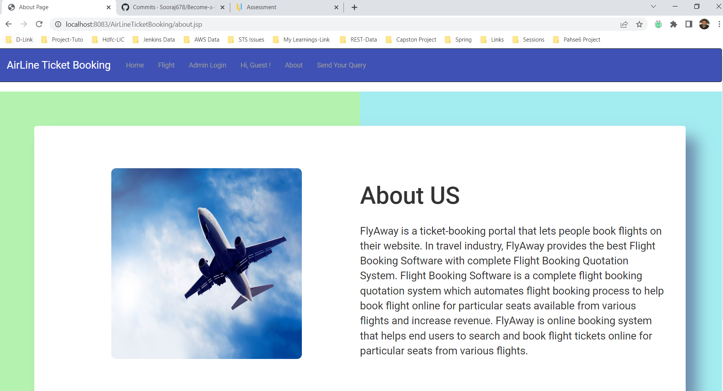

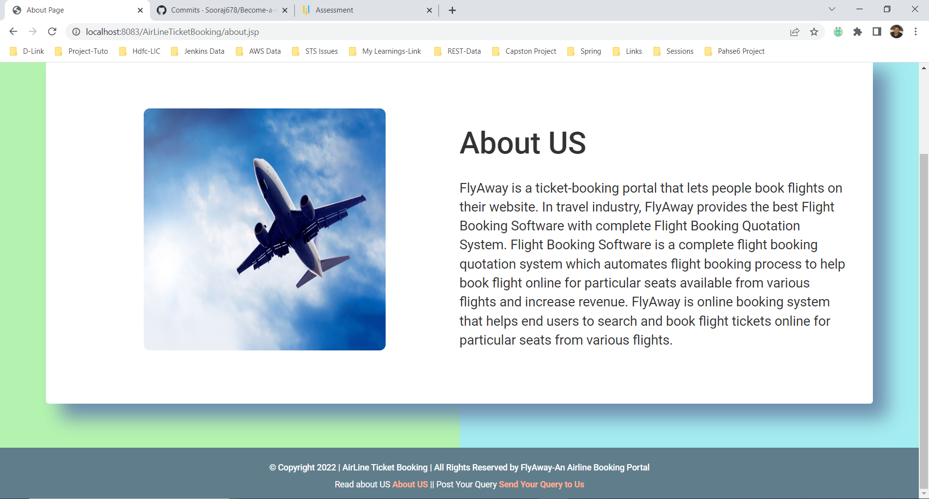

***Admin Login Page***

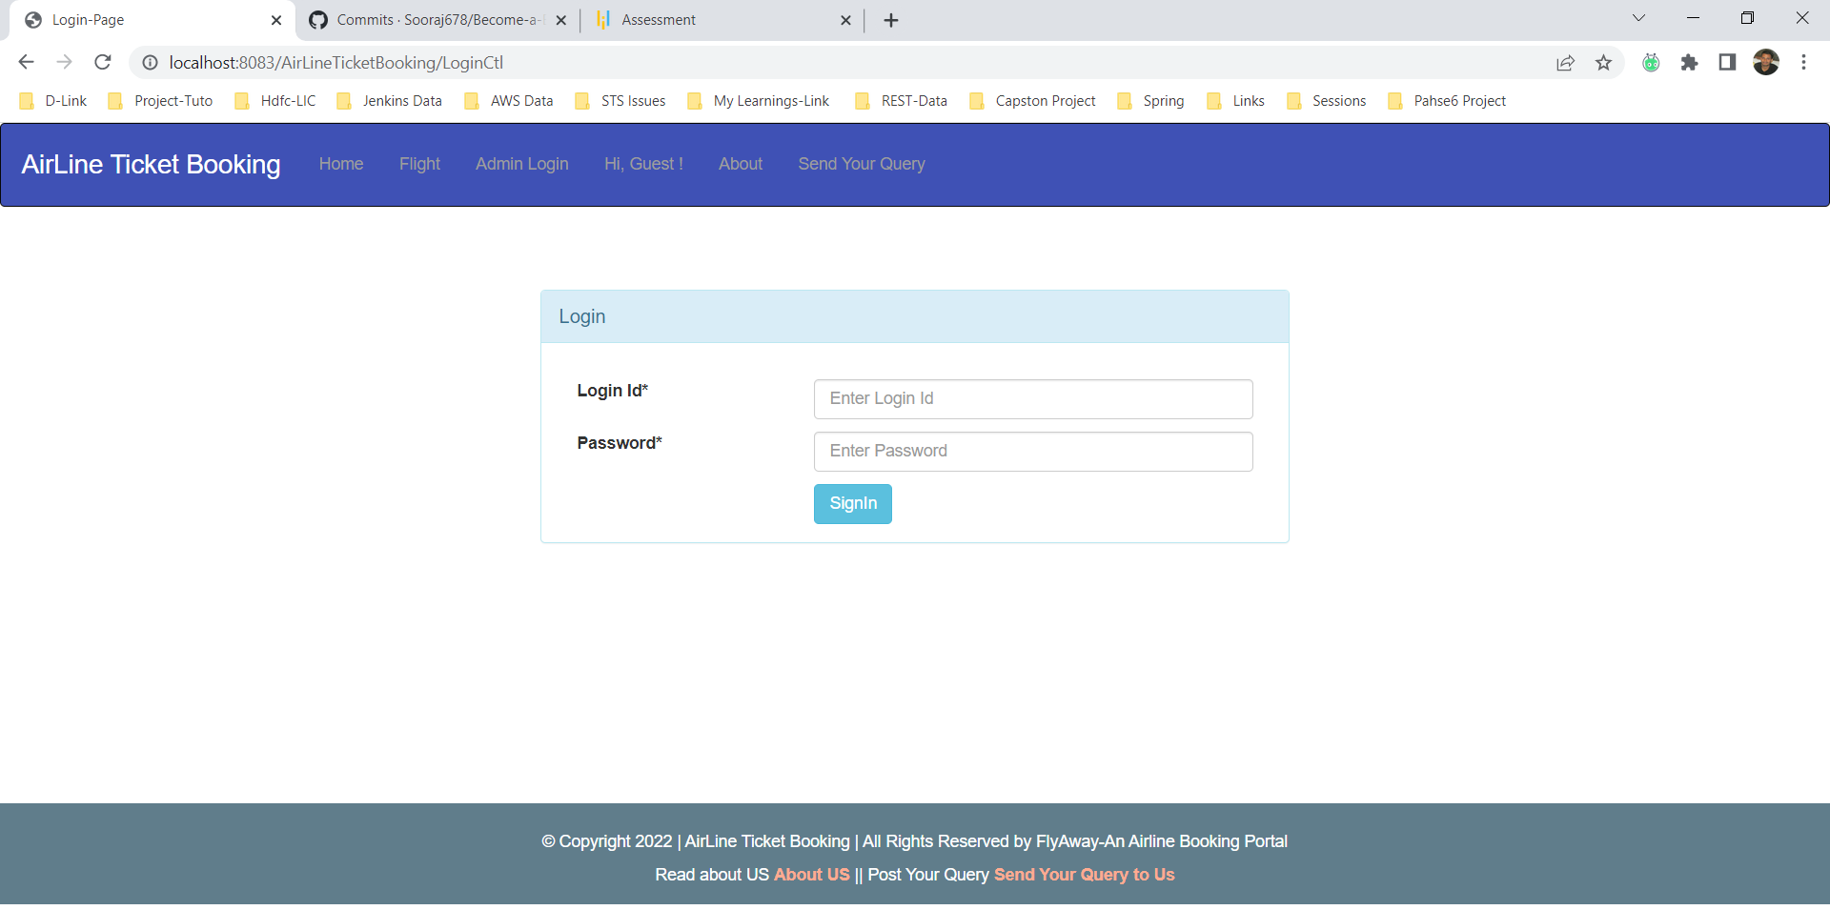

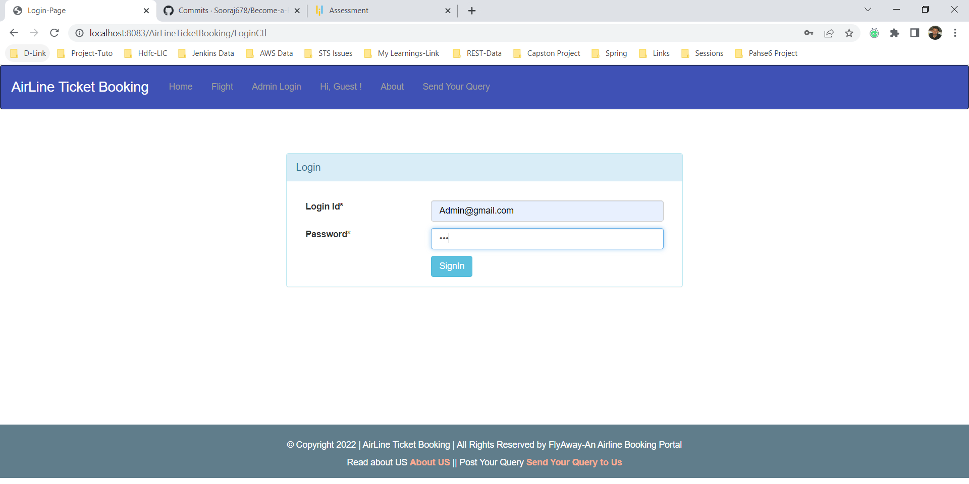

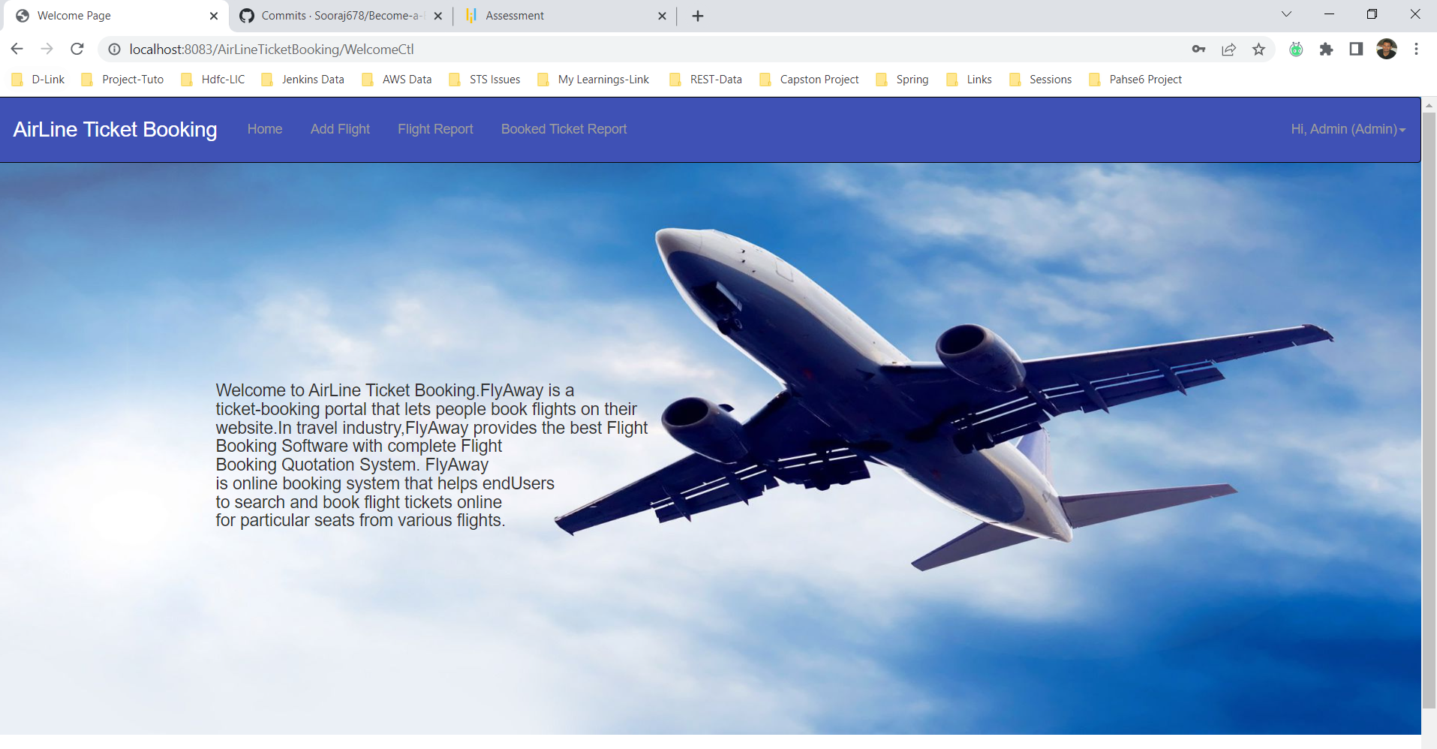

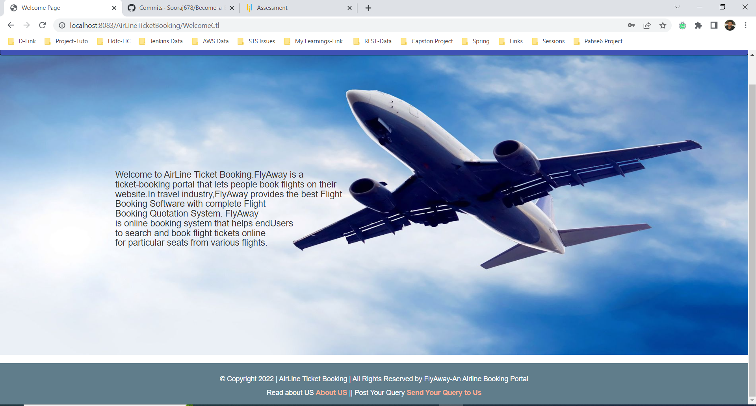

***Add Flight***

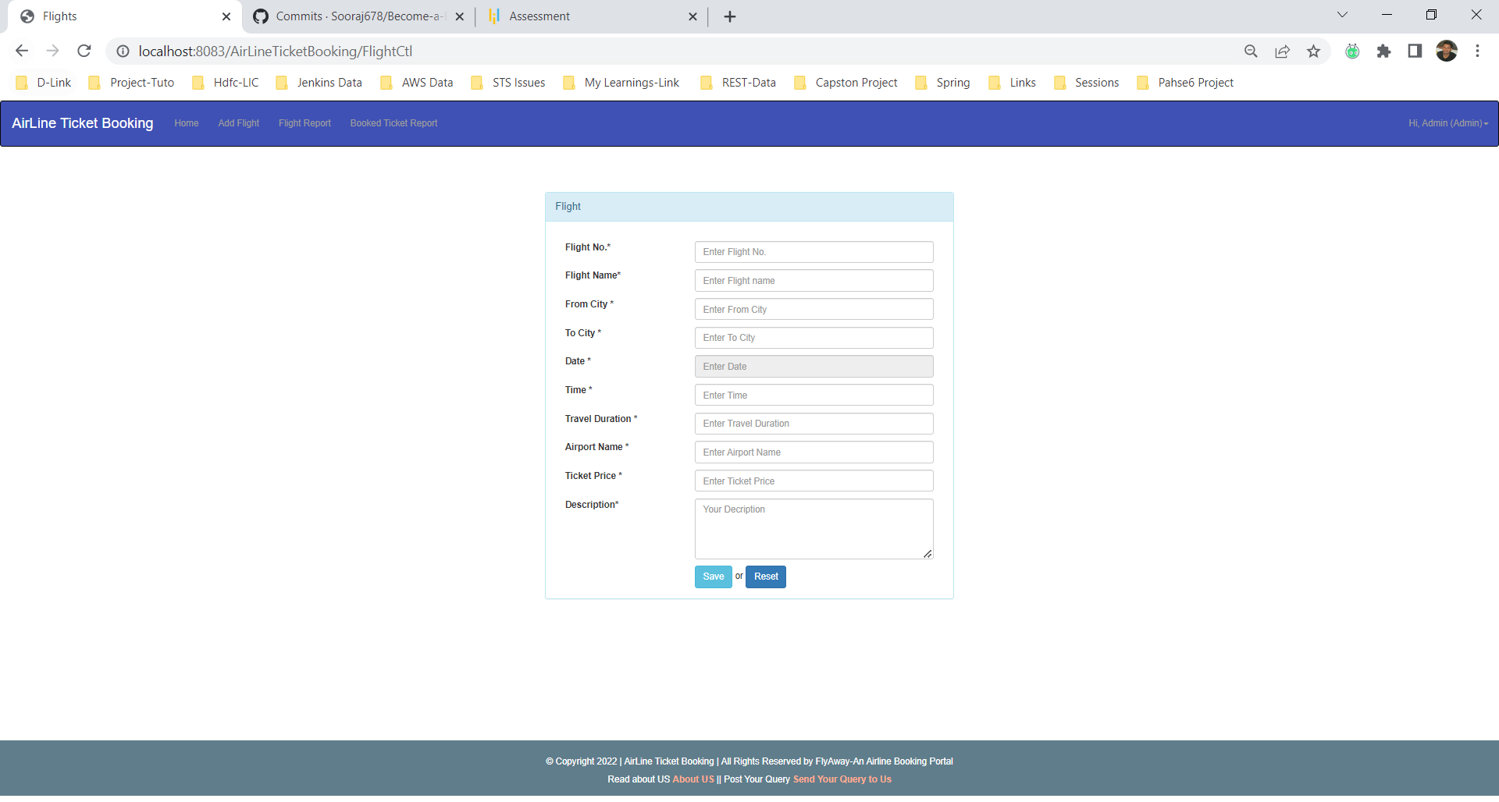

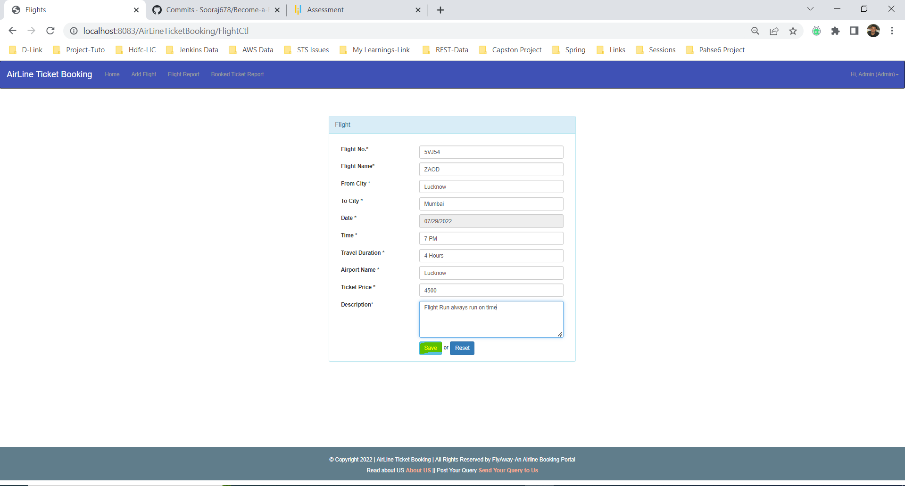

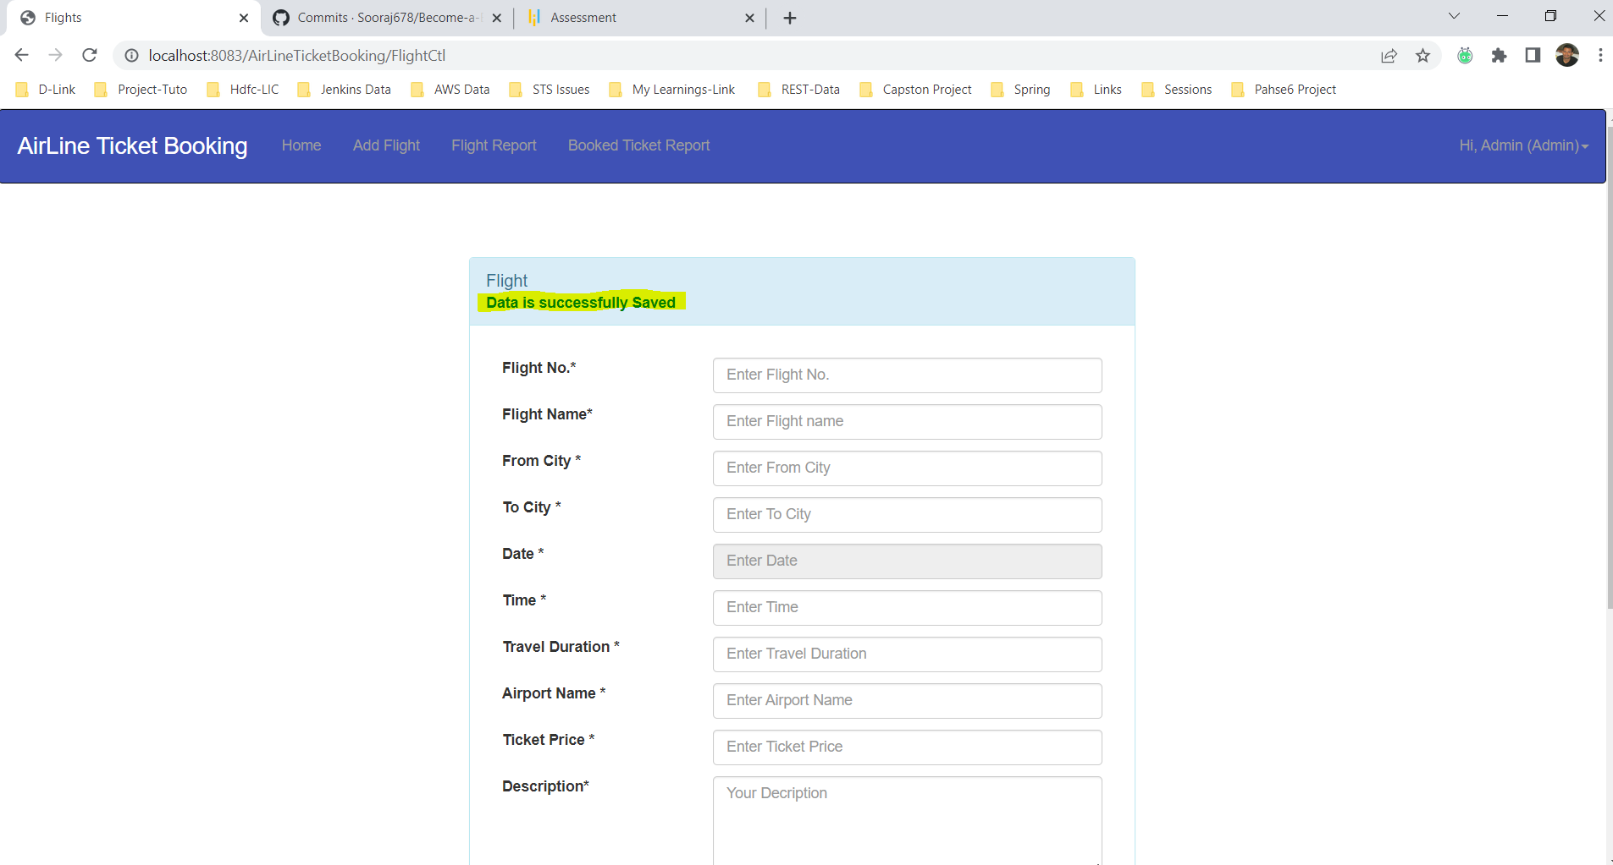

***Flight List***

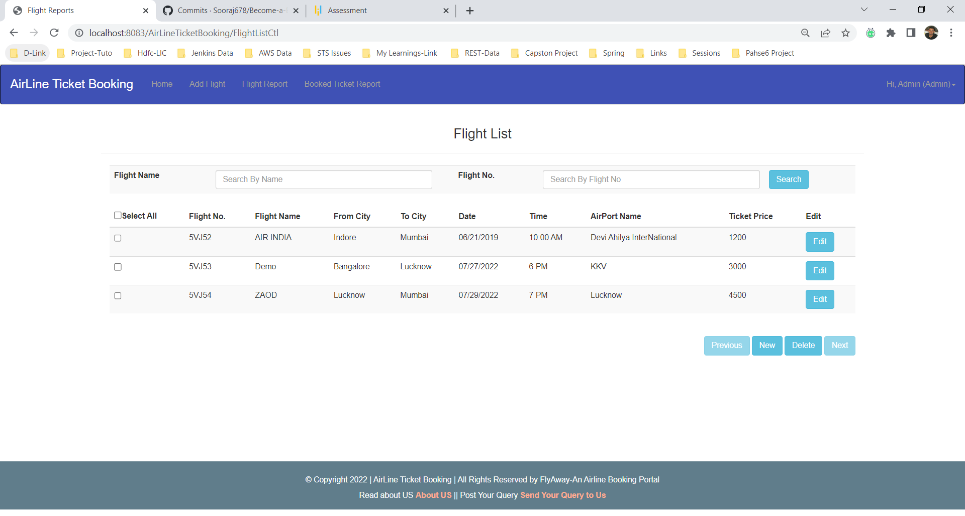

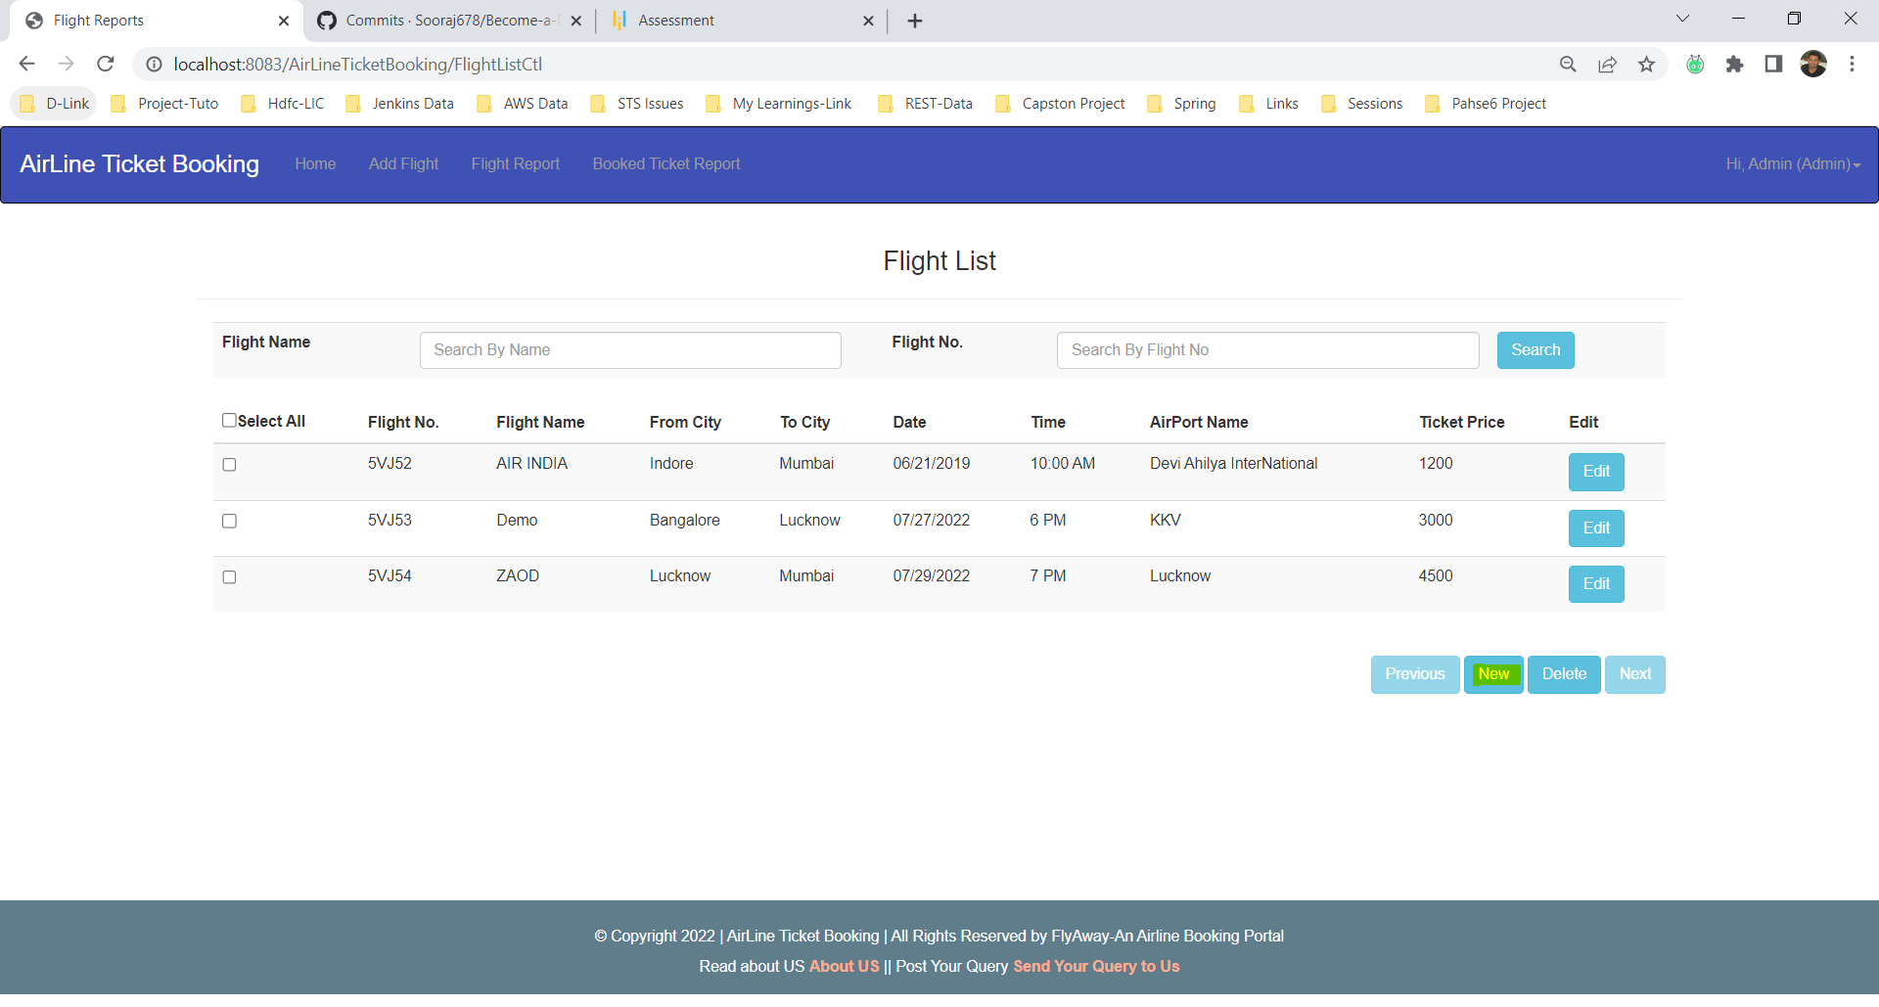

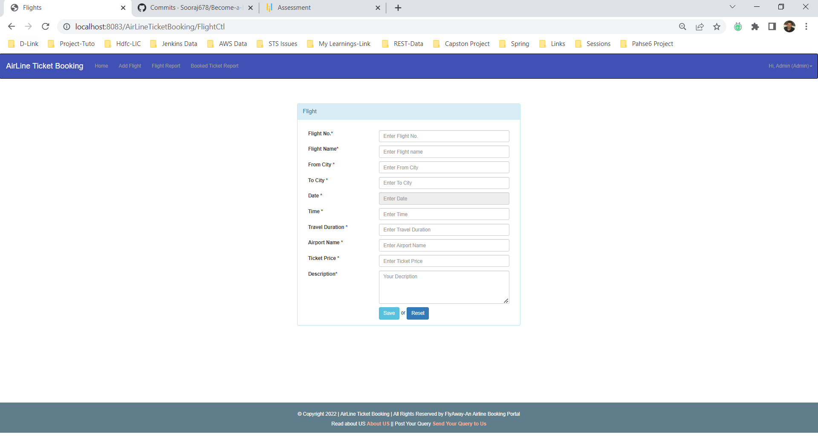

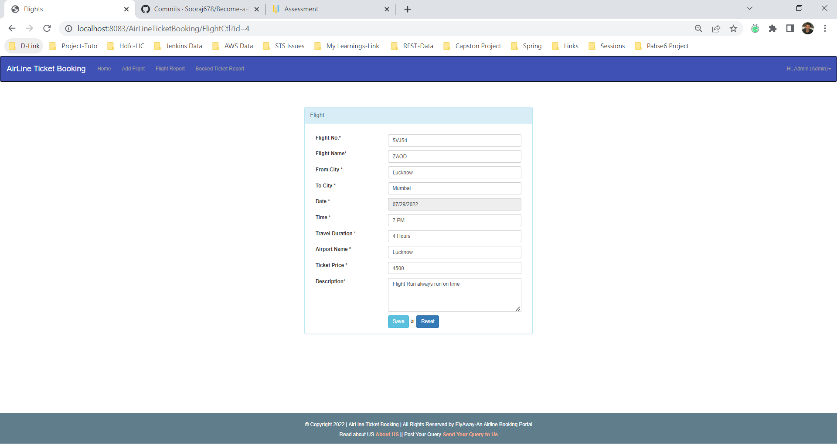

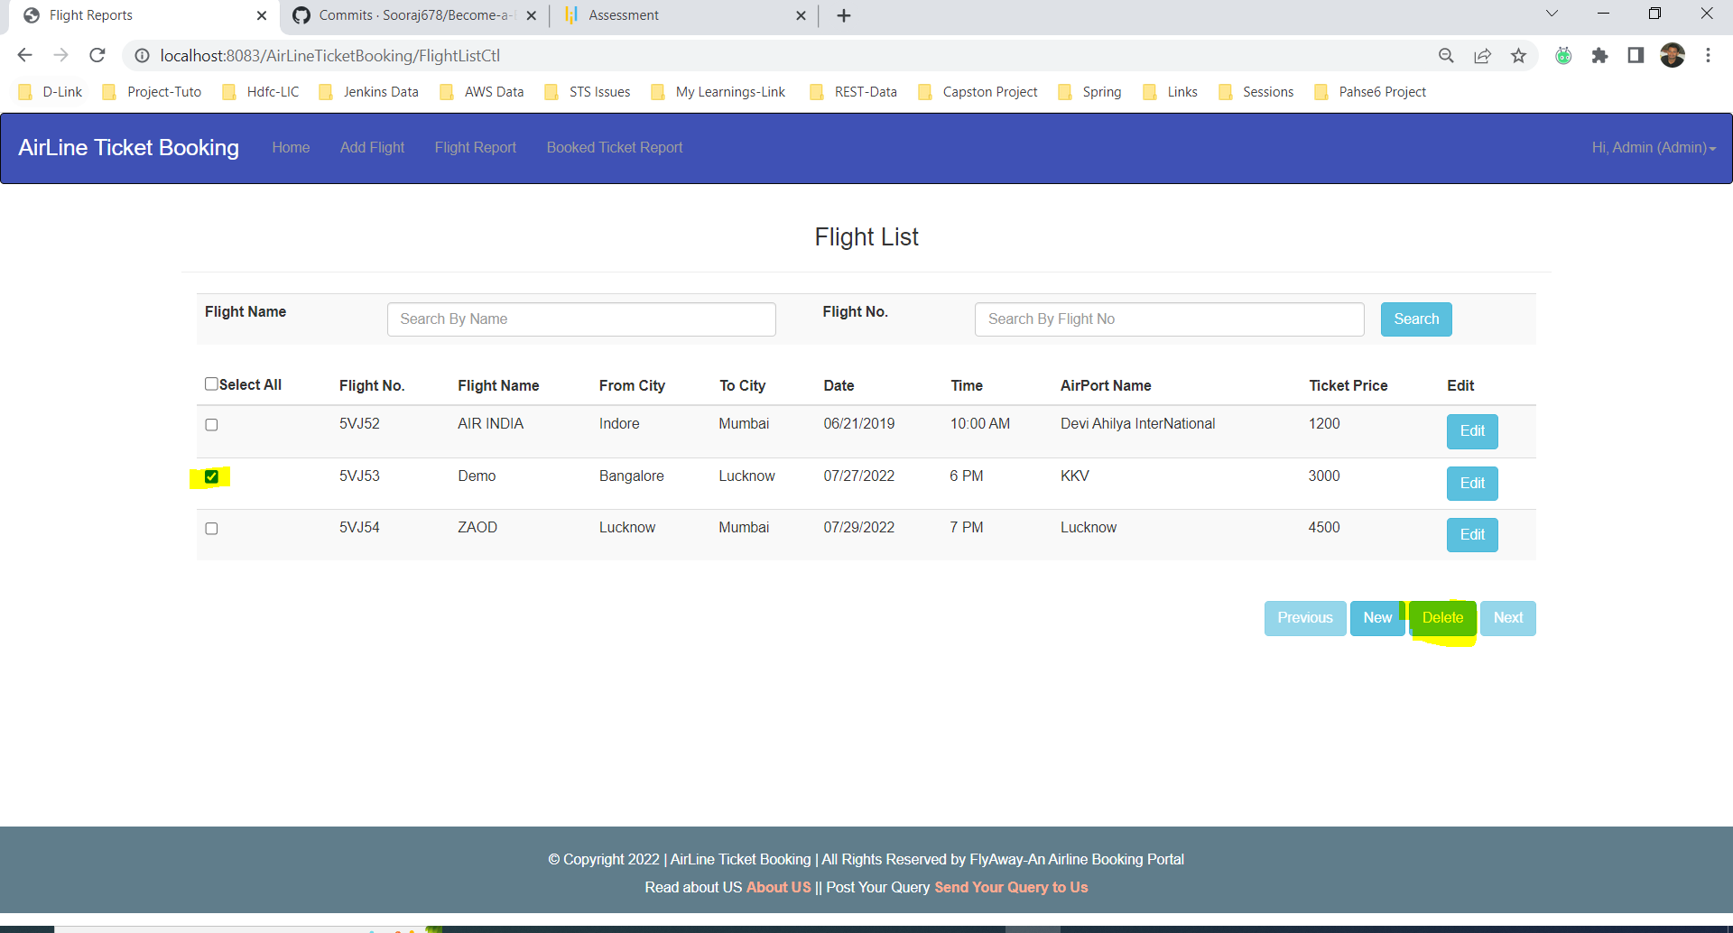

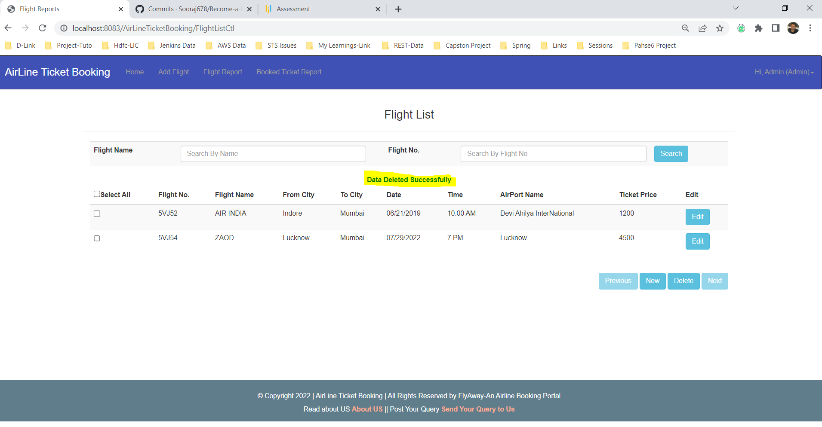

***Search Operation***

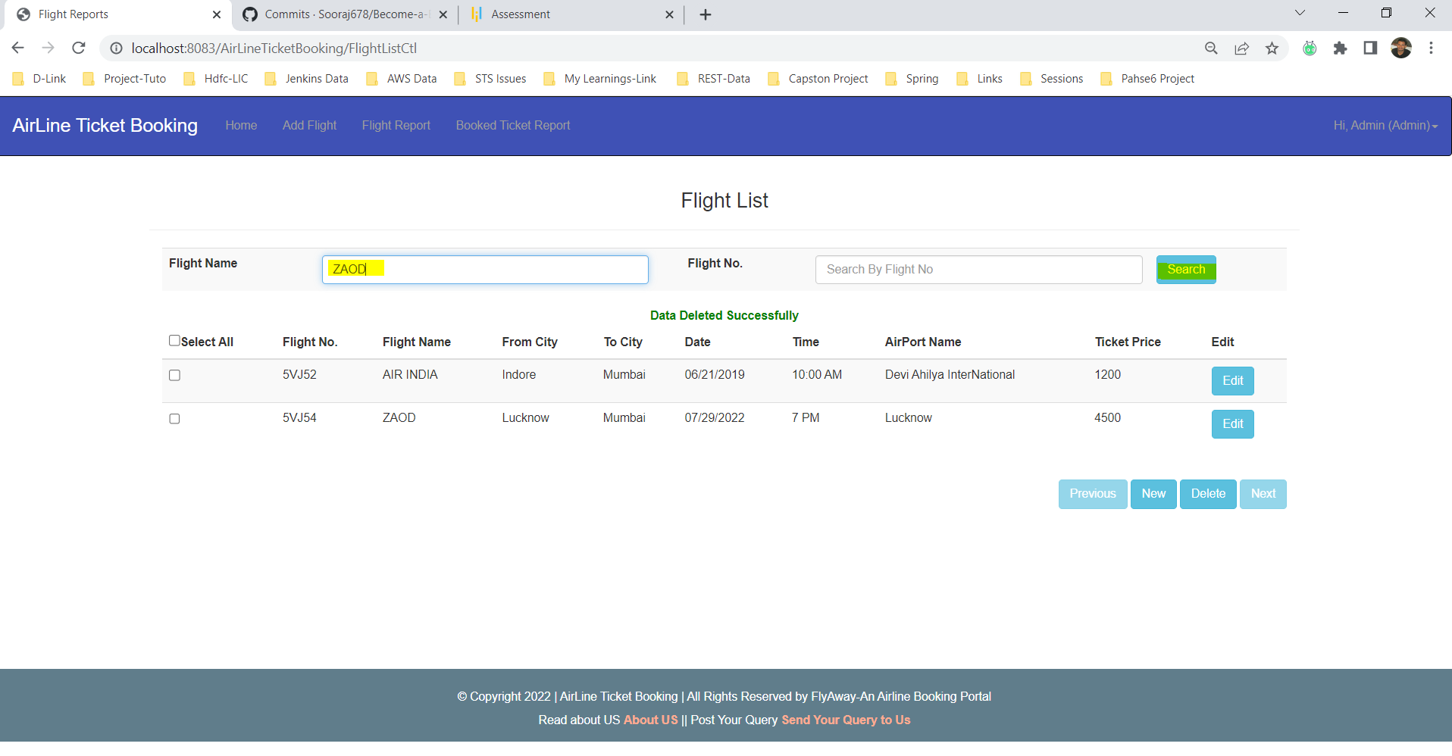

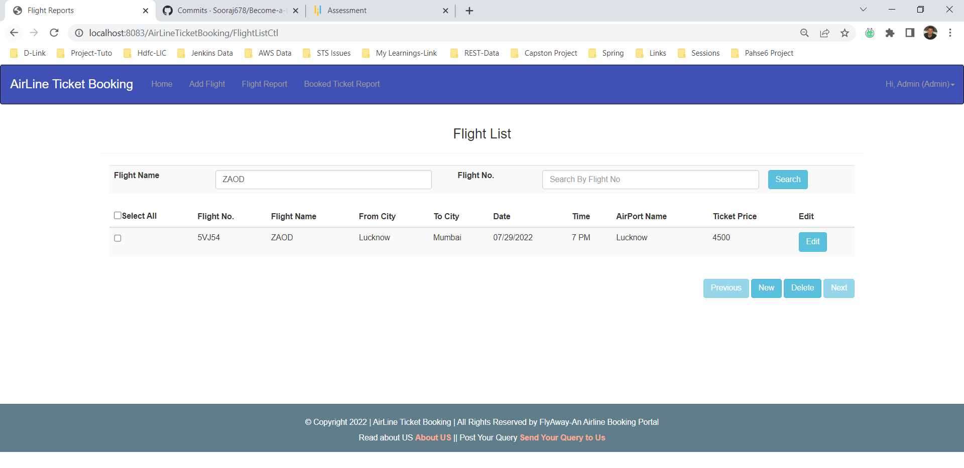

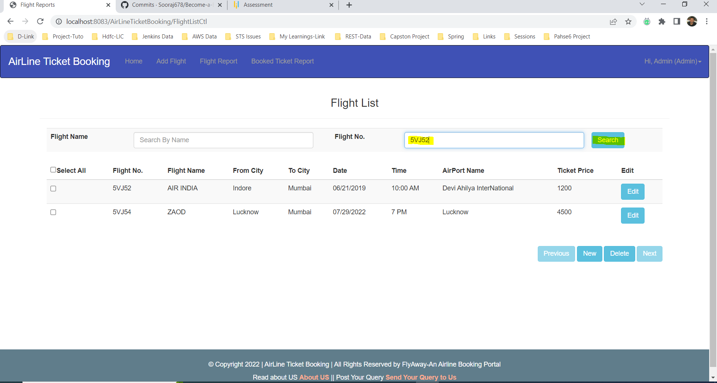

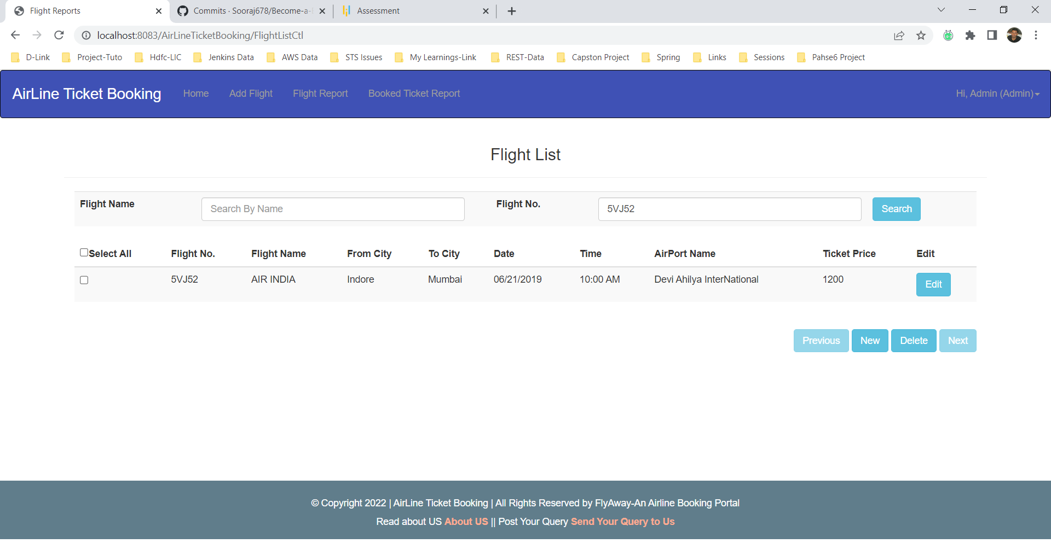

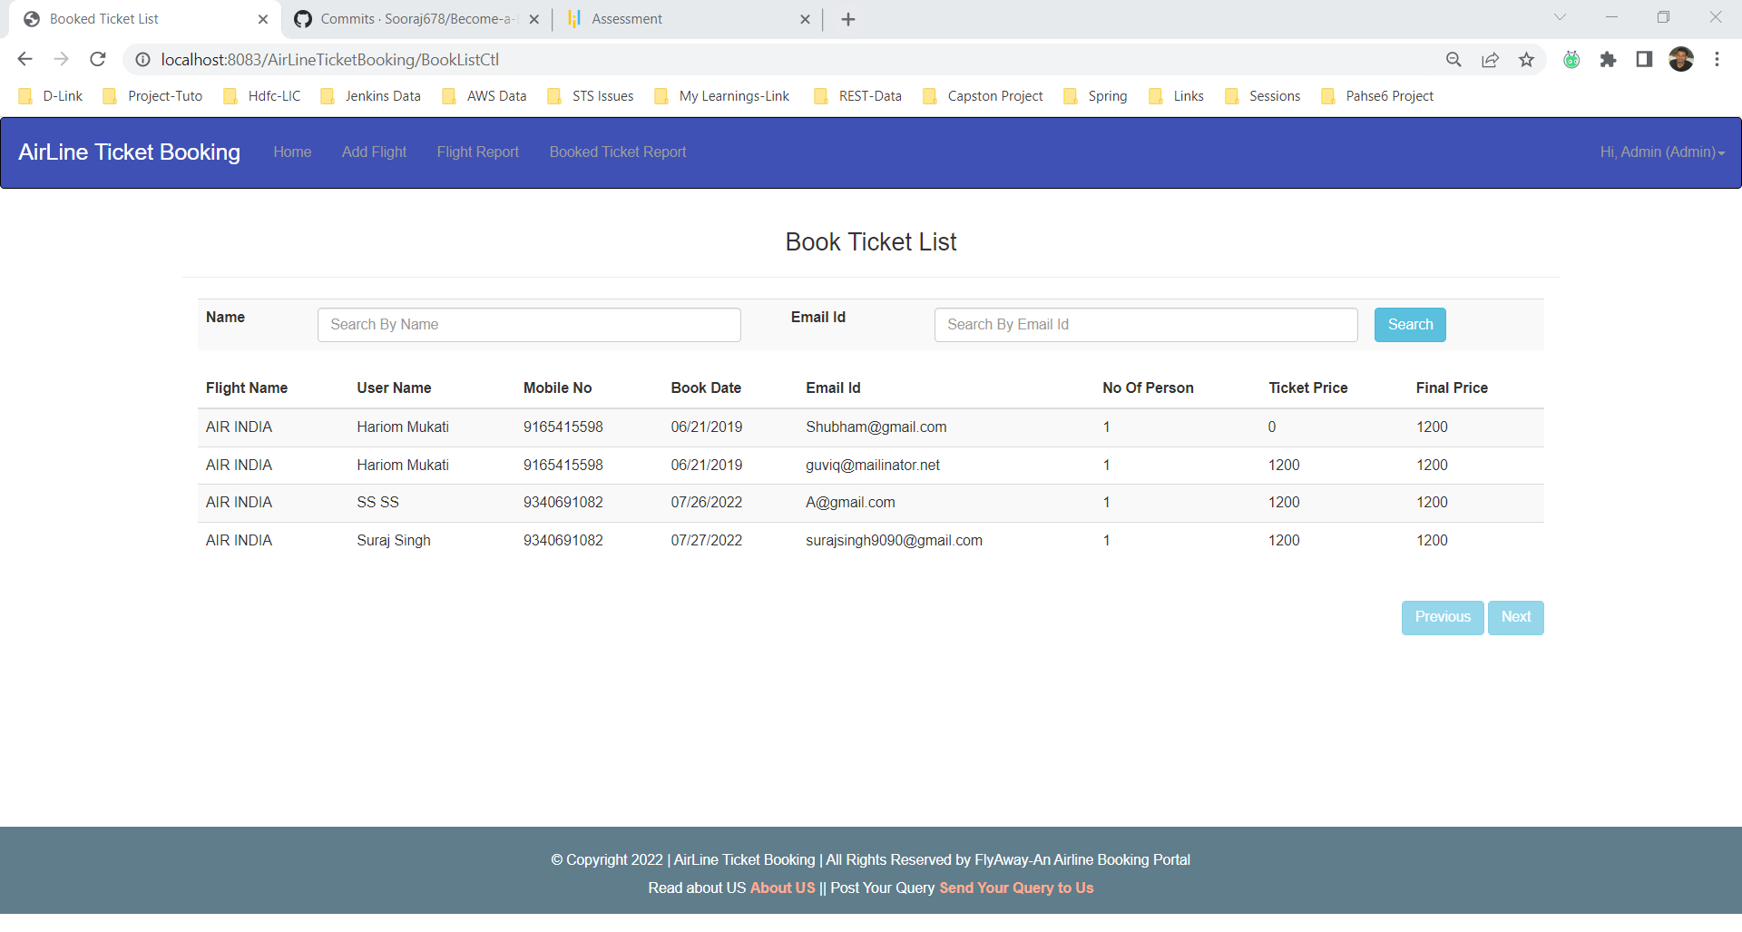

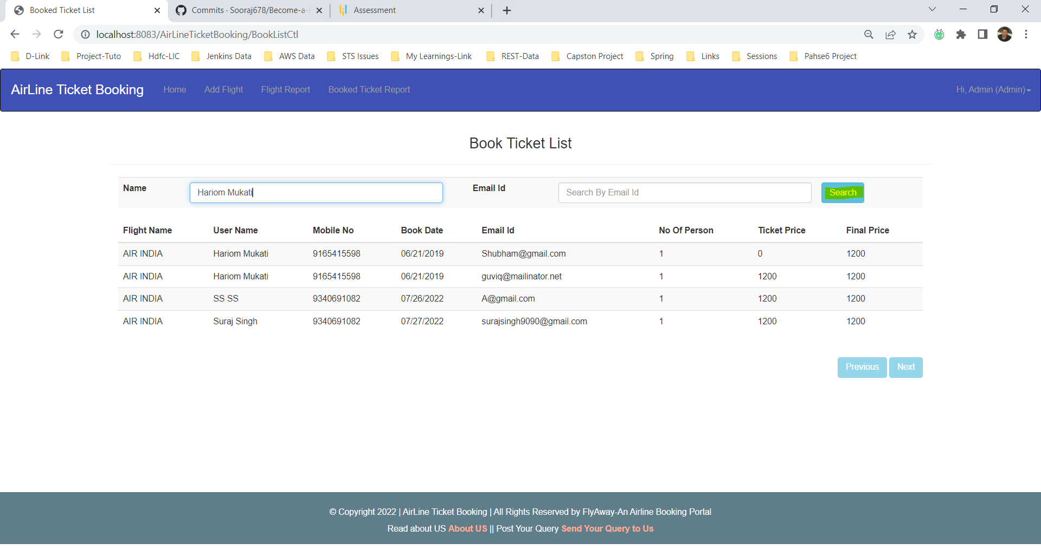

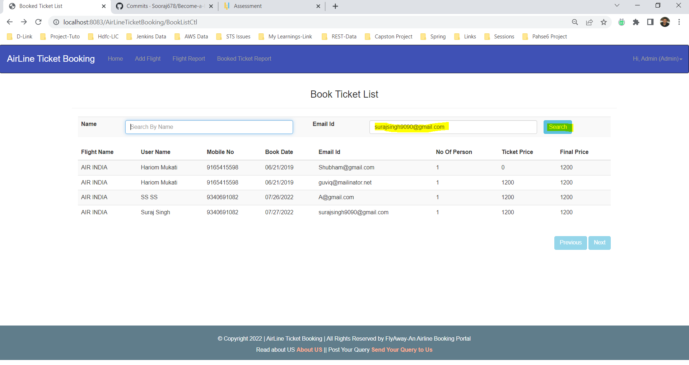

***Admin Password Change***

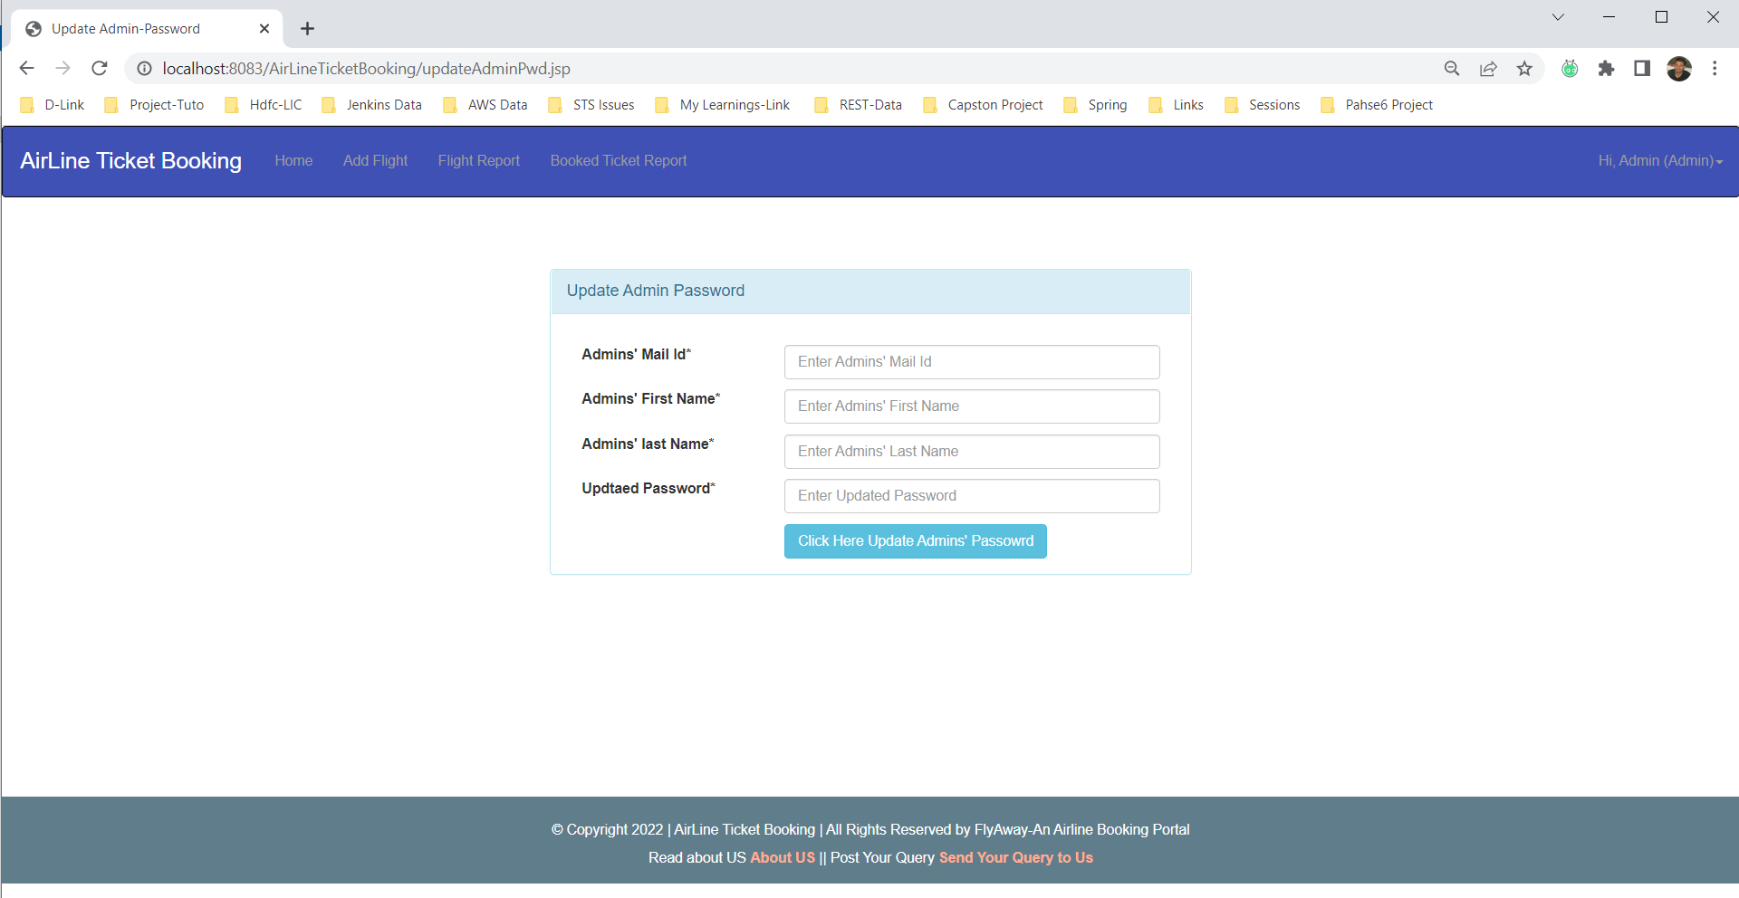

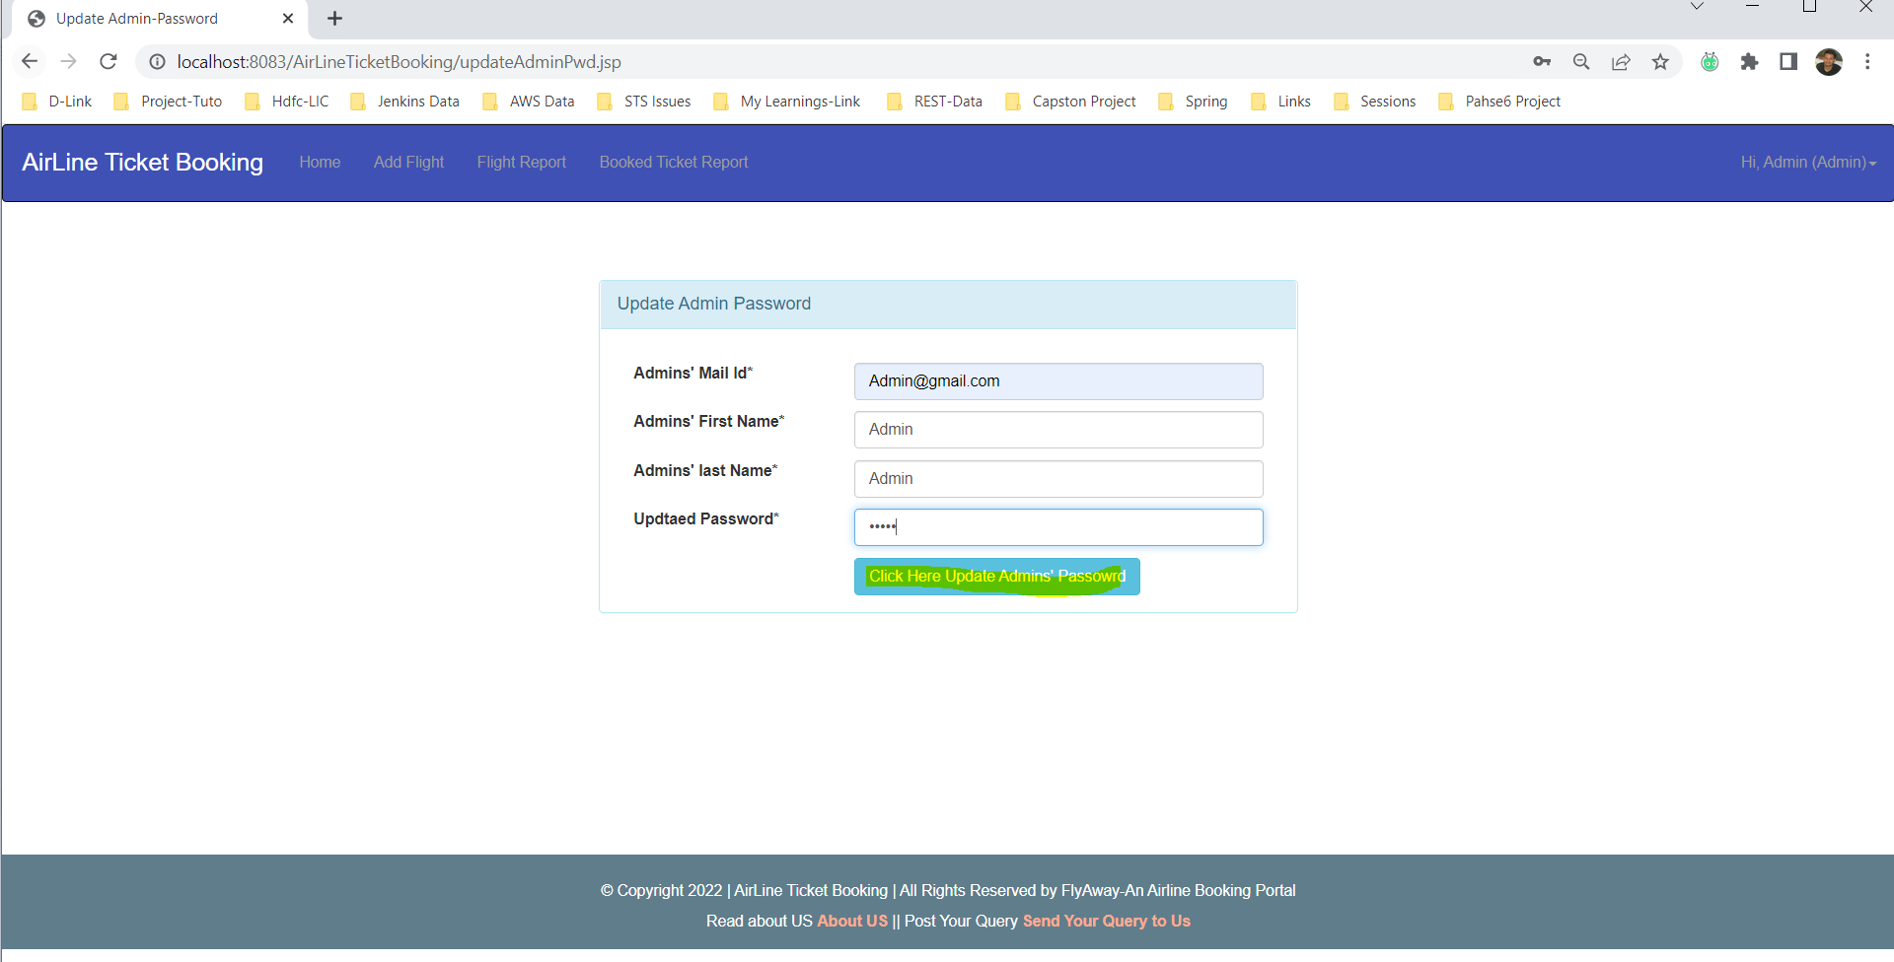

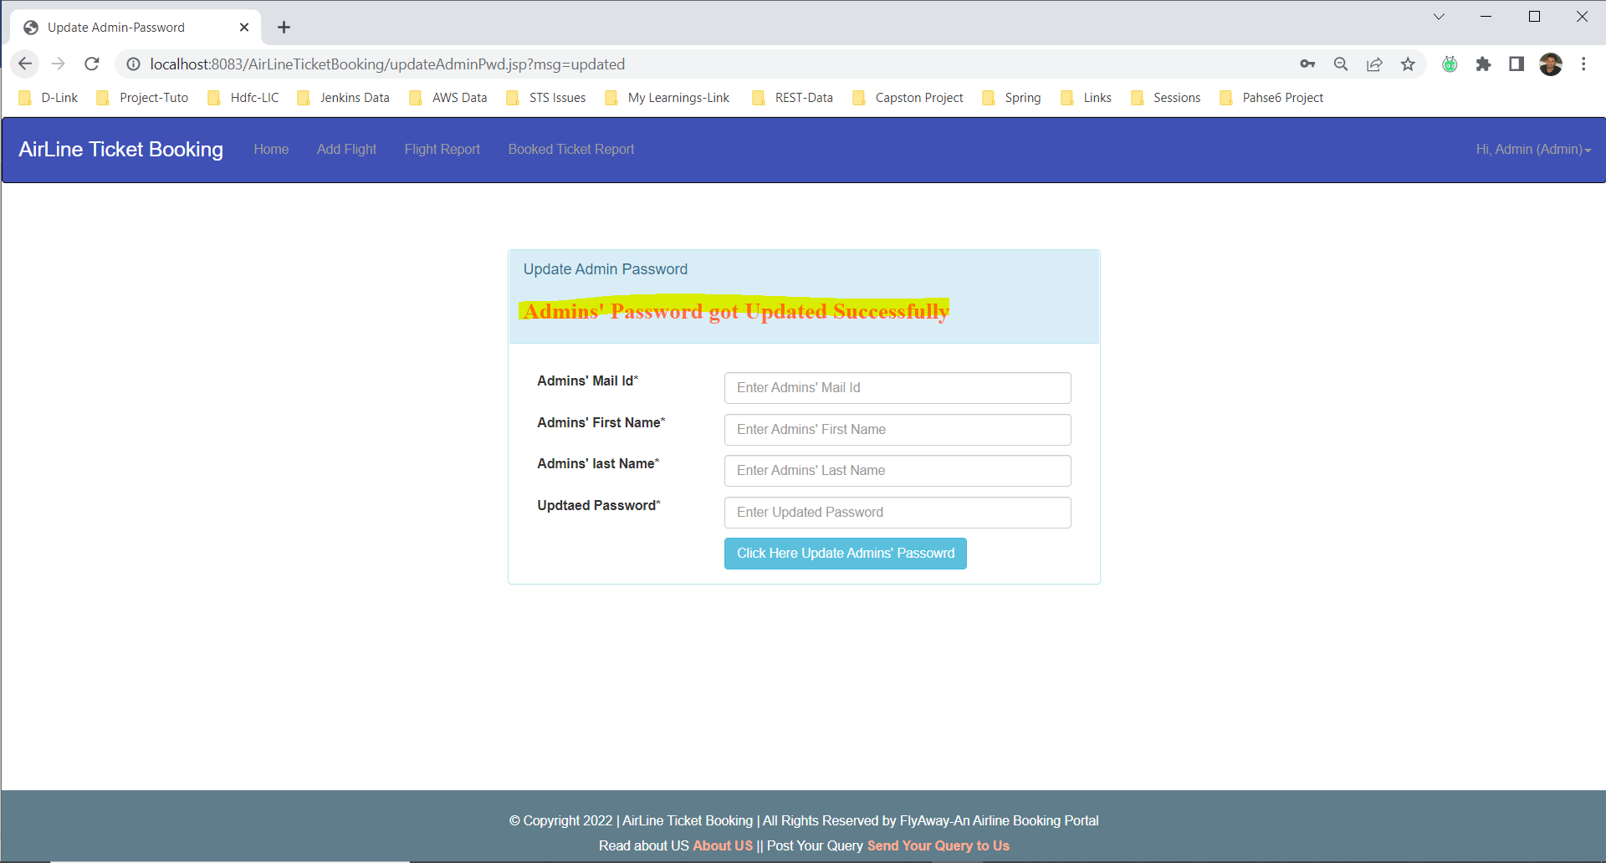

***Admin Logout***

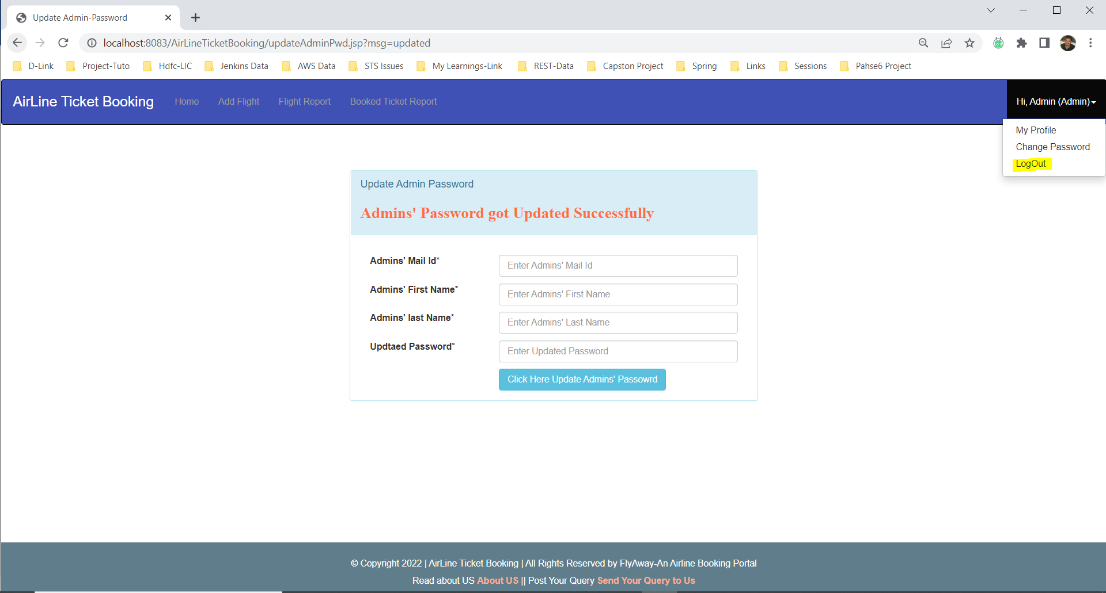

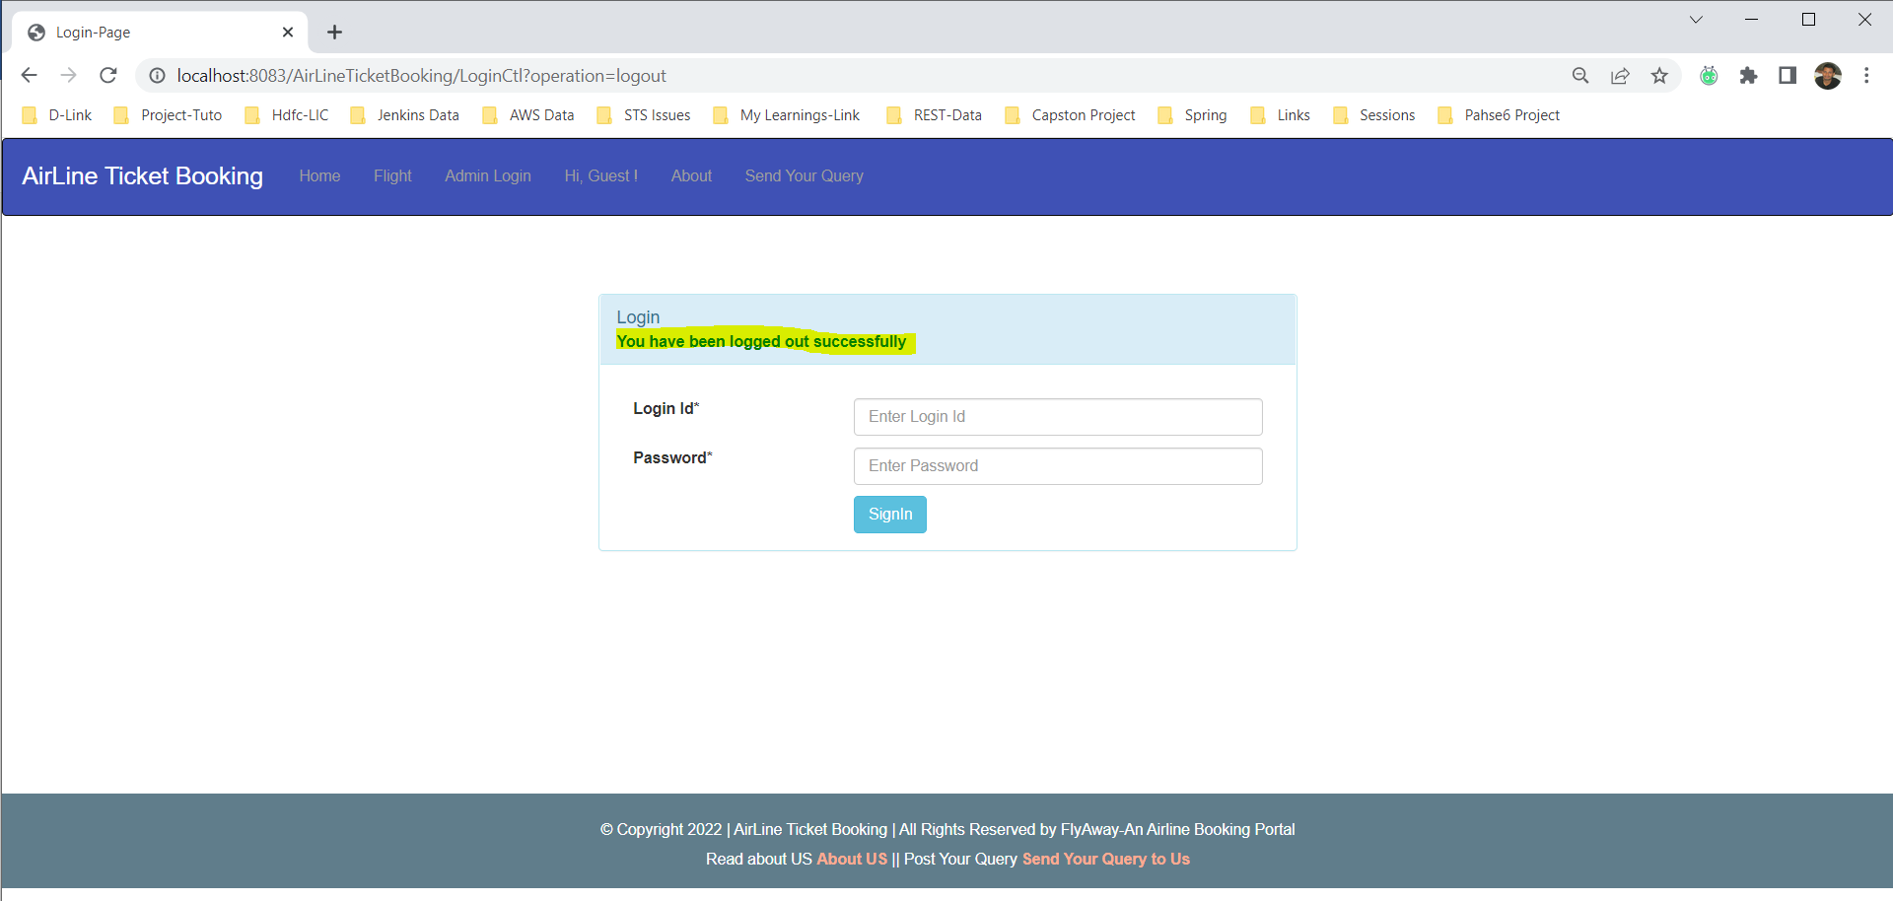

***Book Flight as Guest***

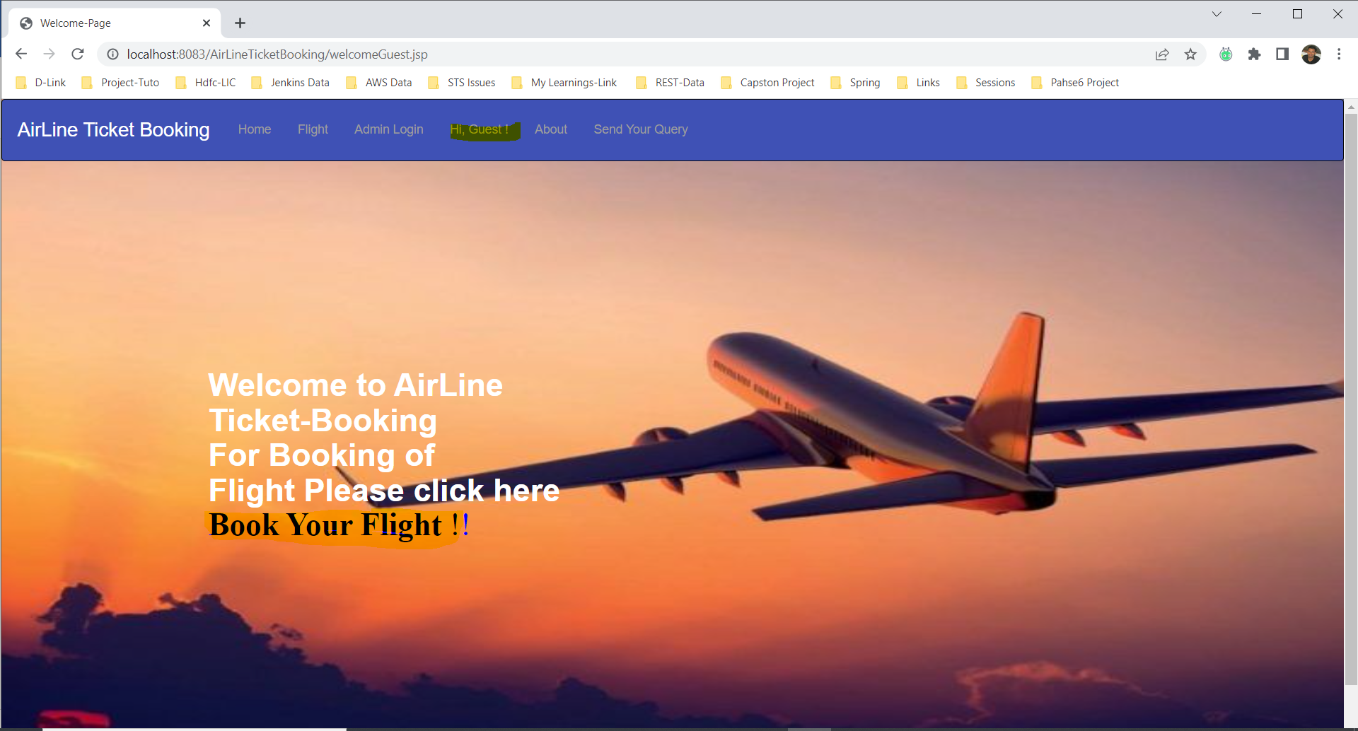

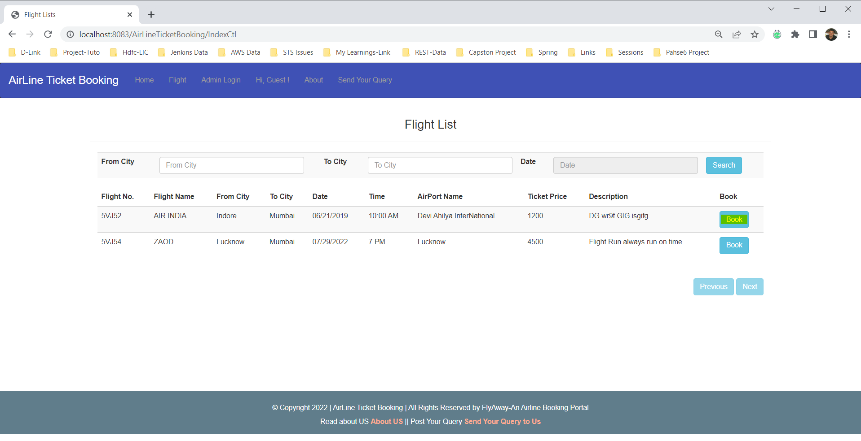

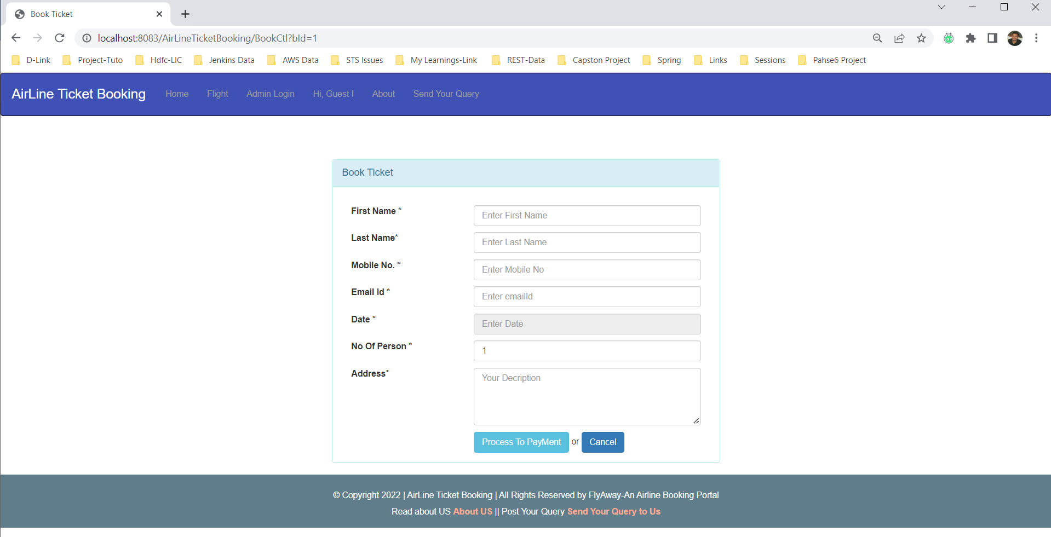

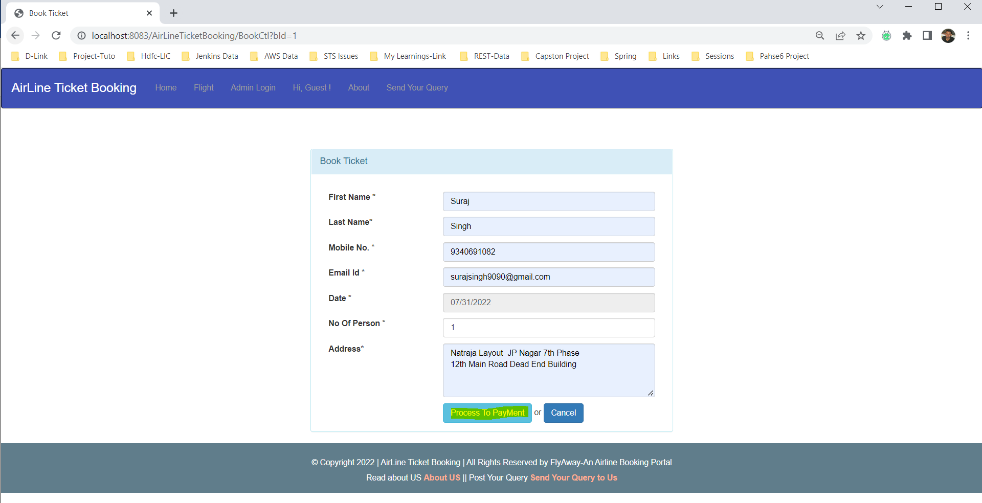

***Dummy Payment Gateway***

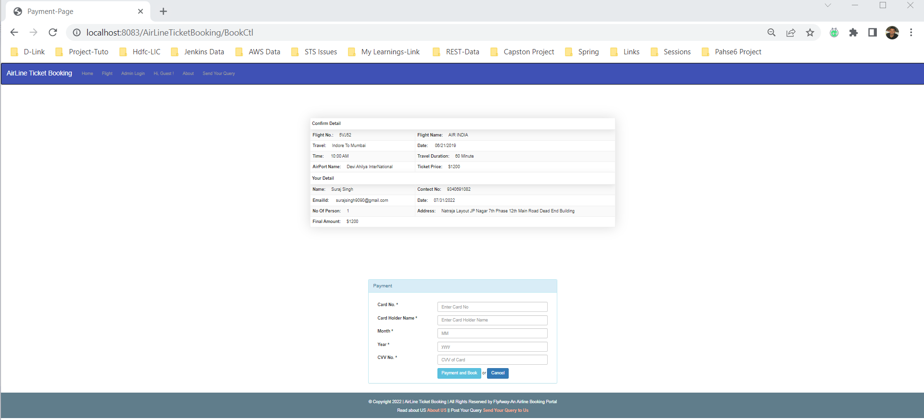

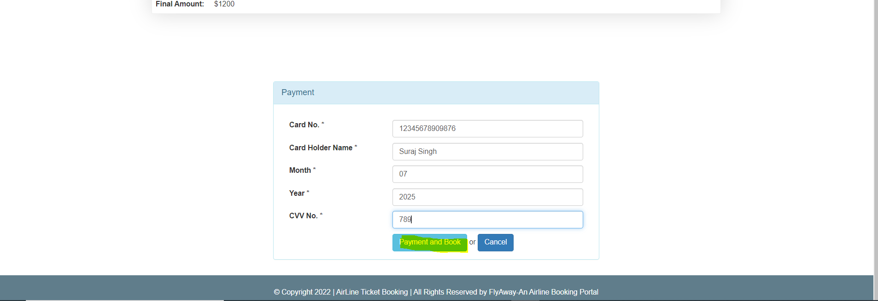

***Booked Ticket***

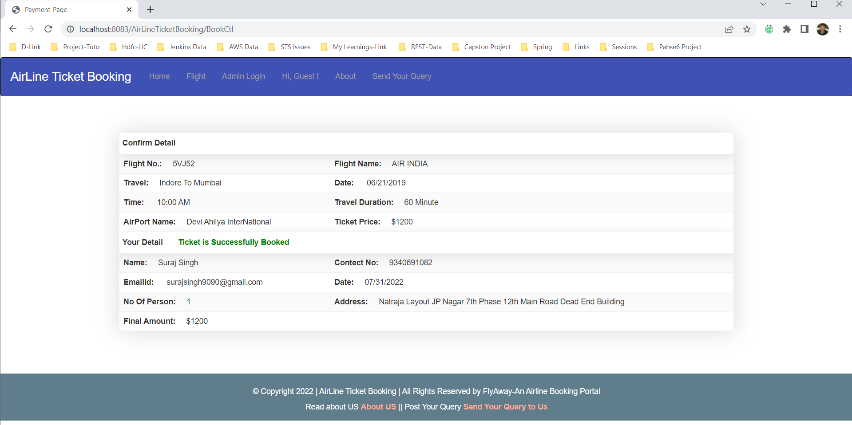

***Contact Page or Send a Query to US***

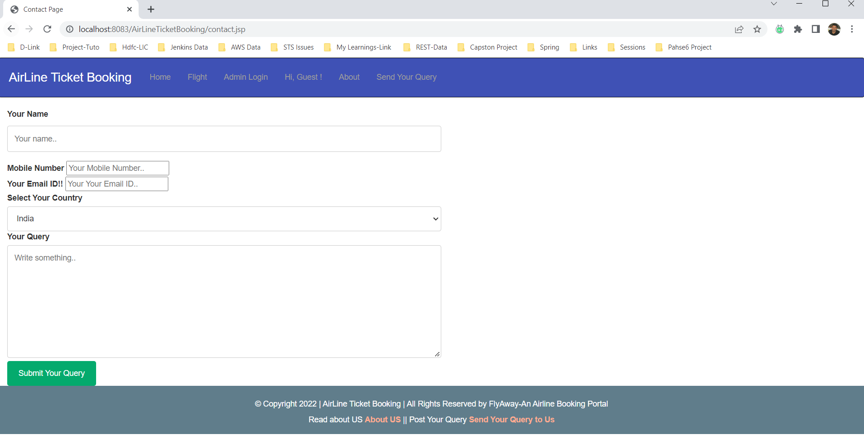

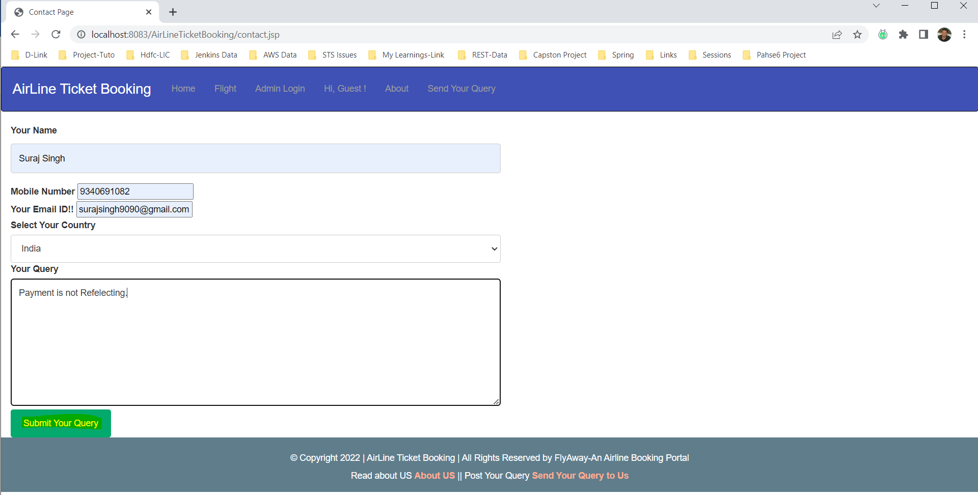

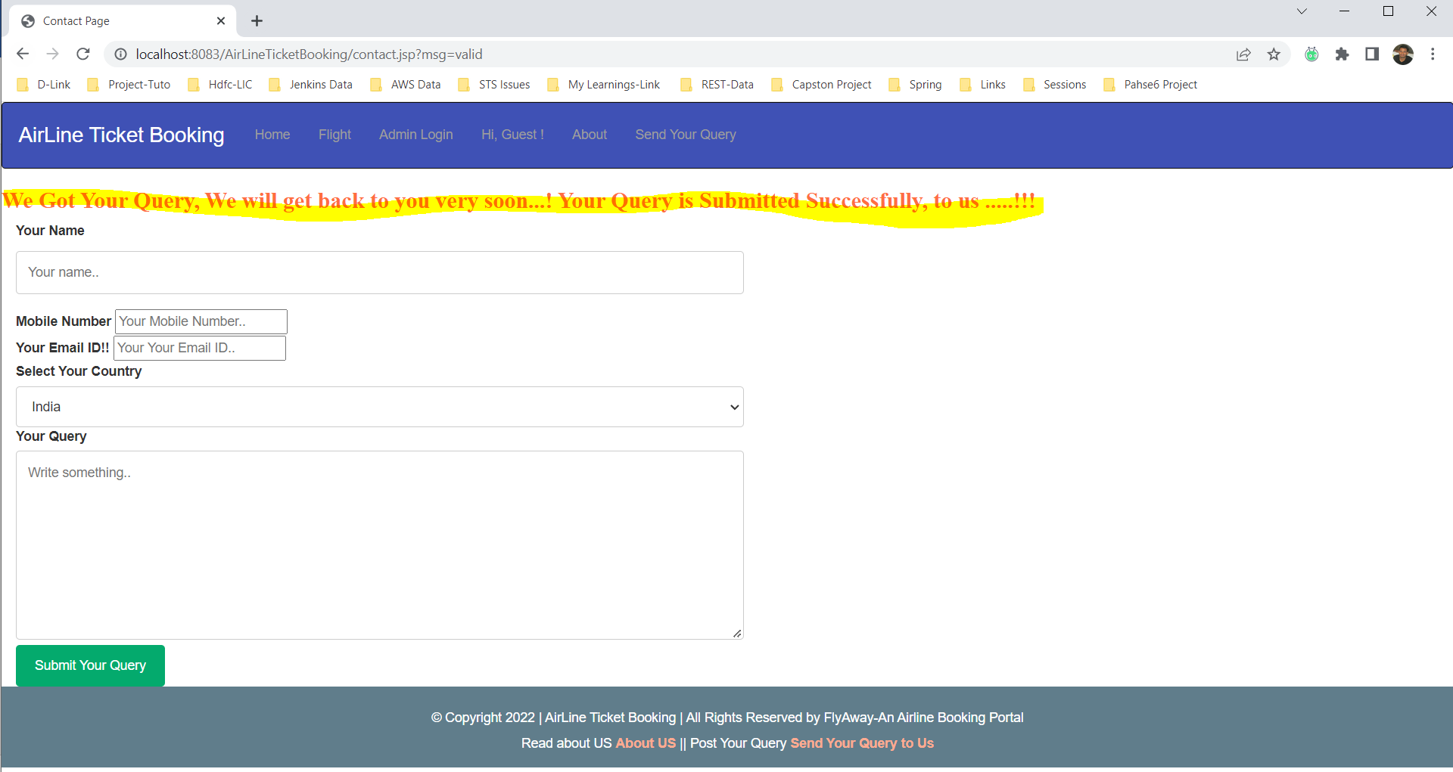

**Database: -**

In order to store the data of the category , contactuser, product, user and purchasedrecord there is a master datatbase called phase6-foodbox.

There are 5 tables created to store the data.

1. a_book: - all the booking details go here.
2. a_flight: - contains all the detail data about flights’ schedule
3. a_user: - contains all the data of Admin User.
4. contactus: - contains all the records of sent queries by customer.

**The Backend (DATABASE)**

**Table 1: -a_book**

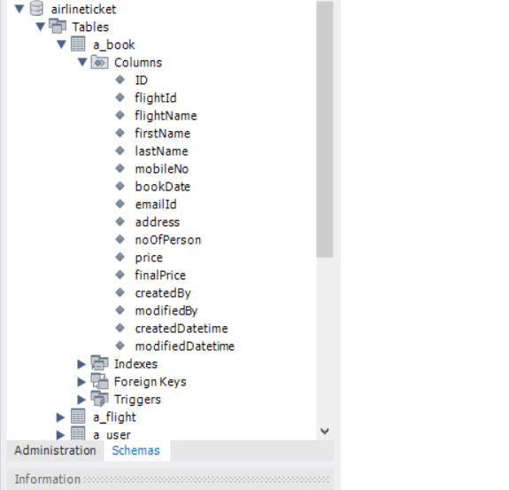

**Primary Key: - ID**

**Not Null: - not any column.**

**Table 2: -a_book**

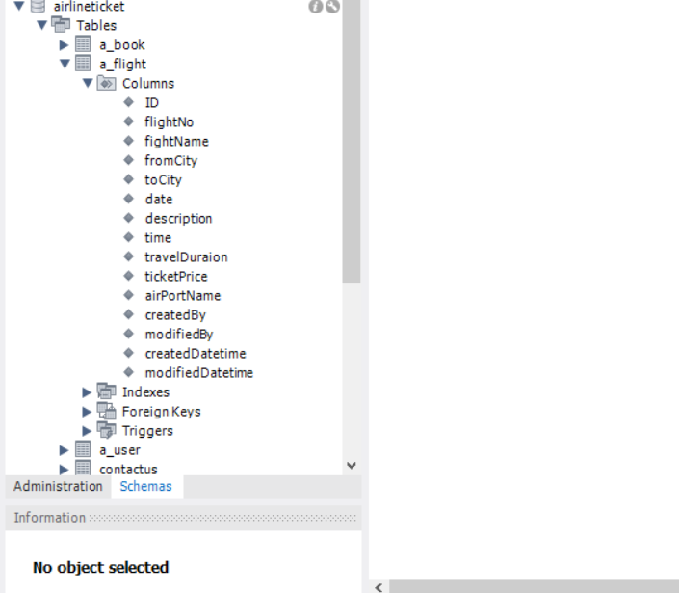

**Primary Key: - ID**

**Not Null: - not any column**

**Table 3: -a_user**

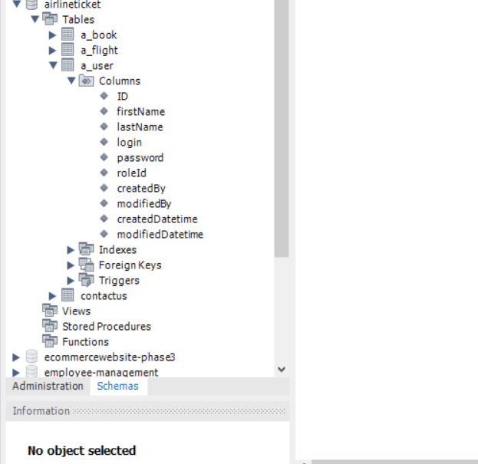

**Primary Key: -ID**

**Not Null: - not any column.**

**Table 4: -Contact User**

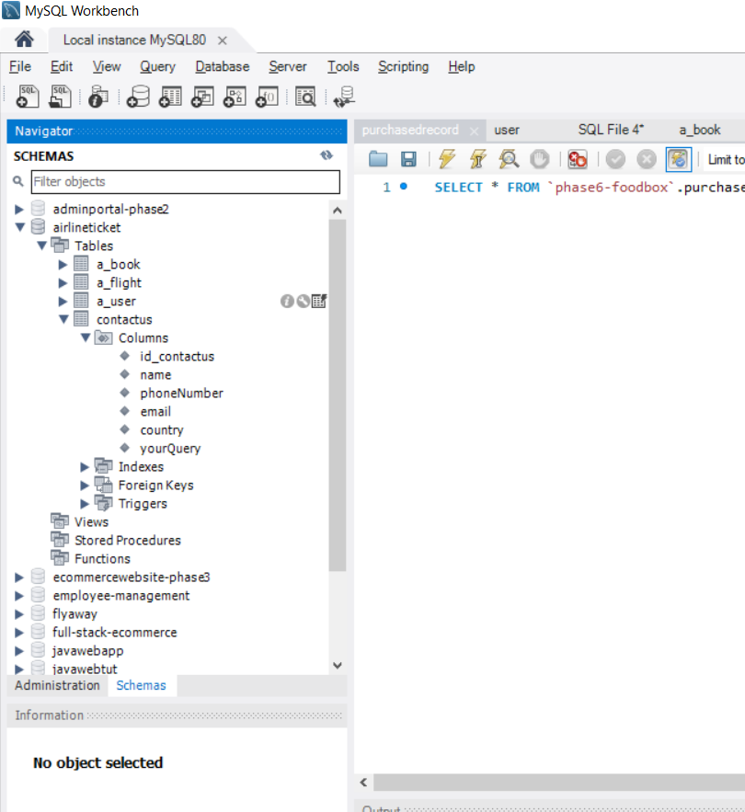

**Primary Key: -id_contactus**

**Not Null: - All remaining ones.**

**6. GitHub links**

This section lists where the source code is located and from where the user can download and use it.

<https://github.com/Sooraj678/Become-a-Back-End-Expert-FlyAway-Airline-Booking-Portal->

<https://github.com/Sooraj678/Become-a-Back-End-Expert-FlyAway-Airline-Booking-Portal-/commits/AllPhases-SimpliLearnProjects>